THE FILMMAKER’S
HOUSE

A film by Marc Isaacs

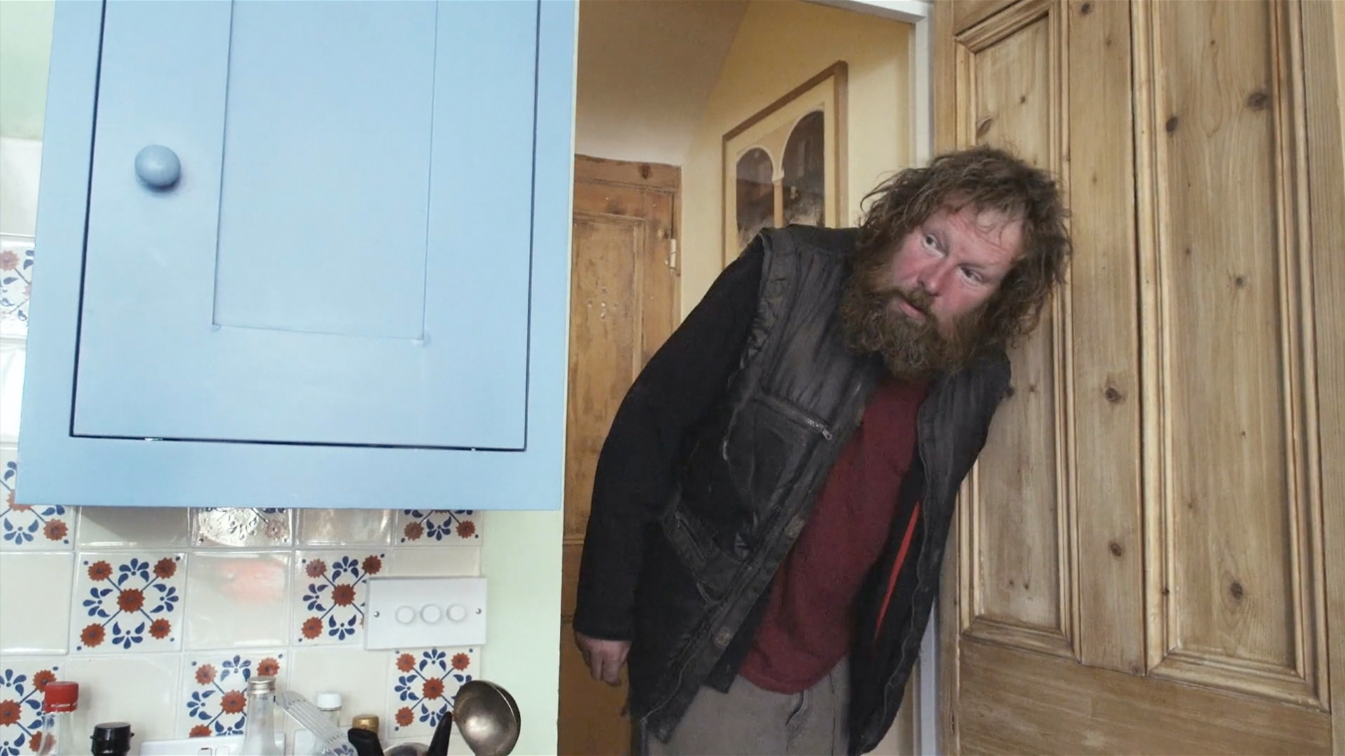

For all publicity enquiries please contact:
alex.rowley@ar-pr.co.uk
Certificate TBC / Running time: 76 minutes

LOGLINE
When the Filmmaker (Marc Isaacs) is told his next film must be about crime, sex or celebrity to get funded, he decides to take matters into his own hands – and make a film in his own home.

SHORT SYNOPSIS
When the Filmmaker (Marc Isaacs) is told his next film must be about crime, sex or celebrity to get funded, he decides to take matters into his own hands. He begins shooting a film in his home, with people connected to his own life becoming its stars: the two English builders, who Isaacs has employed to replace his fence; the Pakistani neighbour, who he now temporarily shares a garden with; a homeless Slovakian man, who invites himself in and tests everyone's ideas of the expectations and boundaries between host and guests in the process; and the Filmmaker’s Colombian cleaner, who is charmed by all who visit. Blending documentary with fiction, and a wry humour with emotional intensity, acclaimed filmmaker Marc Isaacs unfolds a story which asks pertinent questions about the nature of filmmaking itself.

LONG SYNOPSIS
When the Filmmaker (Marc Isaacs) is told his next film must be about crime, sex or celebrity to get funded, he decides to take matters into his own hands and begins shooting a film in his home with people connected to his own life.
The first characters we meet are two English builders, who Isaacs has employed to replace his garden fence, temporarily removing the barrier between him and his Pakistani neighbour. This introduces the film’s central theme of hospitality; a theme that finds its ultimate expression when a homeless Slovakian man charms the Filmmaker’s Colombian cleaner to let him into the house, testing everyone's ideas of the expectations and boundaries between host and guests.
Blending documentary with fiction, and a wry humour with emotional intensity, acclaimed filmmaker Marc Isaacs unfolds a story which - in its’ final act - asks pertinent questions about the nature of filmmaking itself.
DIRECTORS STATEMENT
The Filmmaker’s House was born out of a growing frustration with the state of the documentary film industry and a personal determination to retain independence of mind in my filmmaking. Over the last few years, successful funding for documentary films has been largely determined by how much the filmmaker is willing to deliver the film that the funders want them to make. So we have numerous films about crime and dead pop stars. What has been lost, in my view, is a willingness on the part of funders to back films with a distinct signature - films that take formal and thematic risks. Filmmaking has always been a process of discovery for me and not a commercial endeavour to serve up the predictable old formulas.
When I eventually decided to take the plunge and create a film based in my own home, I invented the film as I went along with the help of a few friends and together we discovered a way of working that was free from the constraints of the 'industry'. I wanted to walk the thin line between documentary and fiction without relying on my own tried and tested formulas and I was determined to dig deep into a new method and to be inspired by the work of those filmmakers who have followed a similar impulse. I have enjoyed the process immensely, precisely because I wasn’t painting by numbers. I have intentionally left many questions raised in the film unanswered in the hope that the viewing experience provokes further thought.
Marc Isaacs

FILMMAKER

Marc Isaacs - Writer, Director, Producer
Marc Isaacs is viewed as one of the top filmmaker’s in Britain to have dedicated so much time to the observation of British lives over an extended period. His work has been written about in numerous books on the documentary form such as Paul Ward’s, The Margins of Reality and This Much Is True by James Quinn. Marc has won BAFTA’S, Grieson Awards and numerous prizes at international film festivals. His filmography includes the multiple award winning Lift (2001): Calais the last Border (2003); All White In Barking (2008); Men of the City (2010) and The Road: A Story of Life and Death (2013). Isaacs’ films look into how people dwell in contemporary, late-capitalist, postcolonial Europe through the notion of a spaced based cinema, whose real and metaphoric values, it simultaneously represents, foregrounds and contests. His work pushes the creative possibilities of the documentary form. Isaacs has had retrospectives in France, Israel and the UK and in 2018 Second Run DVD released a complete box set of his work. Isaacs is an Associate Professor in Ethnographic and Documentary Film at UCL.

Complete Works:
The Filmmaker’s House (2020)
Out of Time Exhibition (Open City Film Festival, September 2017)
Men Who Sleep In Trucks/When Night Falls (BBC 3, July 2016)
Outsiders (Vice, December 2014)
The Road: A Story of Life and Death (BBC, Theatrical Cinema Release, DVD, April 2013)
Outside the Court (BBC 4, April 2011)
The Old Man and His Bed (On-Line April 2011)
Men of the City (BBC4, October 2009)
Cutting Barking (DVD December, 2008)
All White In Barking (BBC2, March 2008)
The Curious World of Frinton-on-Sea (BBC2, March 2008)
Philip and His Seven Wives (BBC4, April 2006)
Someday My Prince Will Come (Arte, France, July 2005)
Calais: The Last Border (BBC2, February 2004)
Travellers (Channel 4, October 2002)
Lift (Channel 4, July 2001)
Lifters (BBC2, September 2001)

DIRECTED by
Marc Isaacs

WRITTEN by
Adam Ganz
Marc Isaacs

With
Zara Akram
Jed Thomas Isaacs
Lucy Kaye
Kevin Lugate
Keith Martin
Mikel Novosad
Daniel O’donell
Luz Nery Villada
Rachel Wexler

EXECUTIVE PRODUCER (Lush)
Matthew Shaw

EXECUTIVE PRODUCER (Bungalow Town)
Rachel Wexler

EDITED by
David Charap
Marc Isaacs

ASSISTANT EDITOR
Dave Briggs

ORIGINAL MUSIC by
Richard Norris
Matthew Shaw

LOCATION SOUND by
Marc Isaacs
Luise Wiehmann

CAMERA by
Marc Isaacs

ASSOCIATE PRODUCERS
Hatty Bell
Erica Edwards

COLOURIST
Claire Winter

SOUND MIX by
Dan Weinberg

MIXING ASSISTANT
Andrew Harris

