BODY OF WATER

A film by Lucy Brydon

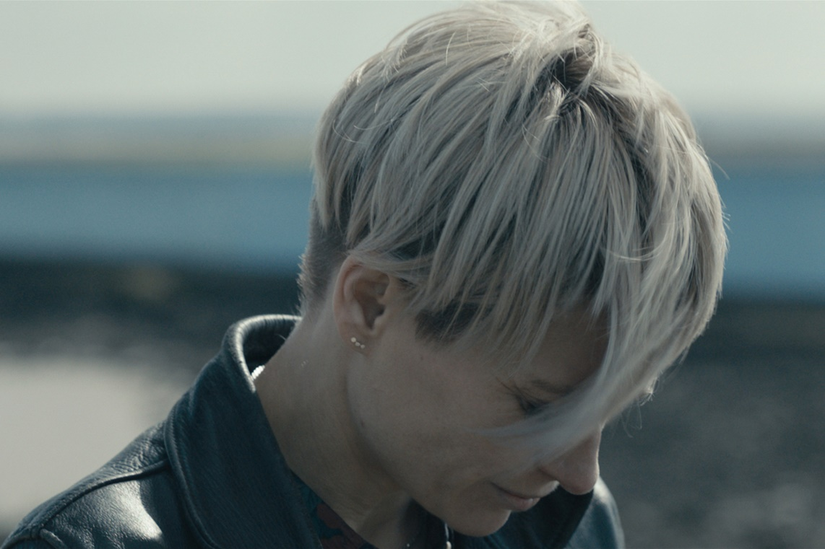

For all publicity enquiries please contact:
chris@chrislawrance.com
Certificate: tbc / Running time: 92 minutes

LOGLINE
A woman tries to balance her relationships with her mother and teenage daughter while under the shadow of an eating disorder in this atmospheric drama from debut writer-director Lucy Brydon.

SHORT SYNOPSIS
Lucy Brydon’s powerful debut feature sensitively explores the impact of an eating disorder on a family.
Having just completed another round of treatment for chronic anorexia, acclaimed war photographer Stephanie (Sian Brooke) is working hard to reconnect with her family. Her mother Susan (Amanda Burton) is supportive but preoccupied by her forthcoming wedding to Annette (Kazia Pelka). Meanwhile Stephanie’s teenage daughter, competitive swimmer Pearl (Fabienne Piolini-Castle), is angry and full of resentment, refusing to give her mother a second chance. Stephanie will need all her strength to keep her head above water.

LONG SYNOPSIS
Acclaimed war photographer Stephanie (Siân Brooke) is being discharged from an in-patient unit after seven months treatment for anorexia – it's not her first admission. In her mid 30s, Stephanie has been suffering from chronic anorexia nervosa since she was a teenager, locked in a destructive relationship with food.
Stephanie’s mother Susan (Amanda Burton) silently drives her back to her home in Canvey Island, Essex. Stephanie is determined to stay well this time for the sake of her 15-year-old daughter Pearl (Fabienne Piolini-Castle), who lives with grandmother Susan (her legal guardian). Pearl, angry and full of resentment, is refusing to talk to her mother.
Still, Stephanie works hard, sticking at her eating plan and group therapy. Her nurse Shaun (Nick Blood) makes regular home visits to check she’s not losing the weight she put on in hospital. Susan is supportive but exhausted after years of picking up the pieces. Stephanie's illness has put a huge strain on their relationship. Susan is also getting on with her own life, blissfully in love and planning her wedding to Annette (Kazia Pelka).
Stephanie begins to slip back into her old ways, drinking cups and cups of water to fill herself up before meals and posting on Pro-anorexia websites. She has lived and worked in war zones, but everyday life is a struggle. Going to the supermarket gives her a panic attack. She finds therapy pointless. Susan notices that Stephanie is losing weight. Pearl too, is hiding secrets. She has her own self esteem issues, sneaking out of the house at night to smoke weed with her drug dealer boyfriend.
At a fitting for Stephanie's bridesmaids dress, her mother’s best friend makes a snide comment about her weight. Other friends tread on eggshells. But nurse Shaun seems to be an ally, helping Stephanie reach out to Pearl. Despite the professional aspect of their relationship, they begin dating. Stephanie invites Shaun to her mother’s hen-do. But after the party, when Stephanie, Shaun and Pearl head to a club, the evening spins out of control.
Susan and Annette’s big day arrives. Stephanie gives a moving from-the-heart speech, but Susan has knocked back a few too many glasses of wine, and isn’t listening. In her drunkenness, she lashes out at Stephanie, opening family wounds.

DIRECTORS STATEMENT
I initially wanted to write a story about eating disorders because of personal experience. Anorexia runs in my family. It was really only when I experienced it myself in my early twenties that I truly understood it. Furthermore, I would go so far as to say the majority of my female friends – and some male – have had issues with eating disorders or body dysmorphia at some time or other. It raises serious questions about how and why this keeps happening, particularly amongst women.

Another motivation of making BODY OF WATER is also to show that it's not just a 'teenage girl' disease. It can stay with someone for their whole life. I’ve met so many women who have massive hang-ups about food. Research shows that 1 in 250 women and 1 in 2,000 men will experience anorexia at some point. Eating disorders have the highest mortality rates among psychiatric disorders and adults face long waits for NHS treatment. The older you get the more entrenched it becomes, the harder it is to break out of. We need to change the conversation around the subject, which was part of my motivation for writing the film.

Over the years the character of Stephanie formulated as I considered the subject: a successful war photographer who has suffered from anorexia throughout her adult life. The present climate is really challenging for women, if you look at all the roles we’re supposed to fill: as mothers, as career go-getters, and then our looks. We’re under so much pressure to conform. Stephanie really struggles with that. That’s why she’s so compelling. Fundamentally, though, this is a universal story about woman who wants to be something that she’s not.

I'm also fascinated with women’s roles in families, how they relate to each other and the complexities of those relationships. That comes from my own family experience, but also just watching my female friends and hearing them talk about their relationships with their mothers.

Stylistically, the film uses a lot of repetition and long takes. This conveys the obsessive-compulsive tendencies and repetitive behaviours associated with anorexia, building a complex character study and hopefully elevating audience understanding of what it’s like to live with an eating disorder. It forces the viewer to sit and endure eating as Stephanie does. This conceit has been influenced by filmmakers including Chantal Akerman’s Jeanne Dielman and Todd Haynes’ Safe. The visual rhythms of the repeated behaviours are key in highlighting Stephanie’s social alienation and relationship with her own body. BODY OF WATER also looks at the effects of Pro-Ana websites on anorexics, providing a timely and unique insight into how web communities exacerbate her problem.

BODY OF WATER is, in many senses, a howl at dysfunctional attitudes to our conventional notions of beauty and the body, taking these themes to an extreme, but arguably logical, conclusion. Ultimately, it poses the question; who or what is really sick, Stephanie or the world she is living in?

Lucy Brydon

CAST

Siân Brooke - Stephanie
Sian Brooke graduated from the Royal Academy of Dramatic Art in 2002. She has an extensive career in television and film, in productions such as THE MOORSIDE, GOOD OMENS, DOCTOR FOSTER, THE FIXER, SILK, CAPE WRATH and HOUSEWIFE 49. She starred in the BBC’s SHERLOCK as master of disguise Eurus Holmes. In 2019 she headlined Channel 4’s drama THE CURE about the Stafford Hospital scandal.
Sian has a rich theatre career including multiple appearances at The National Theatre, the Royal Court, the Almeida and with the RSC in productions of ROMEO & JULIET , KING LEAR and A MIDSUMMER NIGHT”S DREAM. She played Ophelia to Benedict Cumberbatch’s HAMLET at the Barbican in 2015 and most recently, she played Pauline Gibson in David Hare’s IM NOT RUNNING at the NT. Recent film work includes POND LIFE by Bill Buckhurst and Working Title’s Marie Curie drama, RADIOACTIVE, directed by Marjane Satrapi.
Amanda Burton - Susan
Amanda Burton is best known for her long running role as Sam Ryan in the BBC crime drama series SILENT WITNESS, one of the most successful dramas on television and a role that won her the Most Popular Actress award at the NTA’s multiple times.
Amanda first appeared on television in the Chanel 4 soap opera BROOKSIDE as Heather Black. Amanda went on to star as Beth Glover in PEAK PRACTICE, Clare Blake in THE COMMANDER and Karen Fisher in WATERLOO ROAD. Film credits include, BRONSON, opposite Tom Hardy, LITTLE BIRD, POLLYANNA and THE GIFT. Amanda has recently starred in THE LEVEL and can currently be seen in criminal drama, WHITE HOUSE FARM on ITV. Amanda will next be seen in MARCELLA on Netflix.

Fabienne Piolini-Castle - Pearl
Fabienne is a London based actress who recently graduated from university and is continuing to learn more about her craft on every job. She likes to work on independent projects that explore relevant and sometimes sensitive societal issues and so was drawn instantly to The BODY OF WATER. The complex and fiery character of Pearl was both a challenge and an exciting personality to explore, and to which Fab could draw on her own female relationships and personal experiences that related to the prominent themes in the film.
Her film DRAGONHEART: VENGEANCE was released on digital and DVD in February.
Nick Blood - Shaun
Film, television and theatre actor, Nick Blood has starred in shows including BABYLON, MISFITS, TROLLIED, HIM & HER, MATERIAL GIRL and THE BLETCHLEY CIRCLE. He is perhaps best known for his role as mercenary, Lance Hunter in MARVEL’S AGENTS OF S.H.I.E.L.D. Recent credits include HBO’s EUPHORIA and the forthcoming BBC series LETHAL WHITE.
His stage career began as Adam in THE PRIORY at the Royal Court Theatre, followed by Marianne Elliot’s production of WOMEN BEWARE WOMEN at the National Theatre. He later played the lead role, Stuart Sutcliffe, otherwise known as “the fifth Beatle”, in the West End production of BACKBEAT, which also took him to Toronto and Los Angeles.

FILMMAKERS

Lucy Brydon – Writer/Director
From Edinburgh, Lucy graduated from the University of Warwick with a BA in Creative Writing in 2005 before moving to Shanghai. She lived there until 2010, writing, directing, and producing short films, commercials and television dramas as well as learning Mandarin. She then studied Film Directing at Columbia University’s MFA Programme in New York. Her short films have screened at numerous international festivals and her debut novel, SHANGHAI PASSENGER, was published by Blue Mark Books in 2015.
Lucy currently leads the Screenwriting course on the University of Warwick’s Creative Writing Programme, blogs for Little White Lies about filmmaking and is in active development on a number of feature and television projects.
Dan Cleland – Producer
Dan Cleland is a Producer with a background in commercials, features & documentaries. In 2009, Dan produced short film, WASHDAYS, directed by Simon Neal which was nominated for a BIFA. He co-produced David Leon’s directorial debut, ORTHODOX, produced by Daisy Allsop. The micro-budget feature starring Stephen Graham and Michael Smiley was released in 2016. ARE YOU PROUD? a feature documentary directed by Ashley Joiner, produced by Dan exploring the fifty-year history of LGBTQ+ Pride in the UK was released in the UK in 2019. The film was named one of the Top 10 best documentaries of the year by The Guardian & Dan was long listed for Breakthrough Producer at the British Independent Film Awards.
In 2020 Dan took part in the Screenskills Co-Producer Programme on Two Brothers Pictures BAPTISTE Series 2. Written by Jack and Harry Williams & Cat Moulton, Directed by Thomas Napper and Hong Khaou and Produced by John Griffin, the BBC series stars Tcheky Karyo and Fiona Shaw.

Jeannette Sutton – Producer
Jeannette is a creative producer who freelances producing content in advertising whilst also developing her own slate. Having started out in film marketing, Jeannette has traversed a variety of roles within the film industry. A few include Agent's assistant at Independent Talent, Film Festivals including Sundance & MIFF, 3rd AD on Hong Khaou’s LILTING and Tom Harper’s WARBOOK). Upon producing her first short, THE BISCUITMAN’S WIFE it became clear that the role of producer was most suited.
BODY OF WATER is Jeannette’s first feature producing credit and she currently has many narrative short and feature projects in development, with a particular focus on female filmmaking talent.
Film London Microwave
Microwave is Film London’s renowned feature film scheme. It serves to inspire and develop the capital’s best new filmmakers, empowering them to make bold, compelling features that will surprise and inspire global audiences. The scheme was the first low budget feature program in Europe and has been responsible for discovering and developing some of the UK’s most exciting talent.
Lions Den Films
Lions Den Films was founded in 2008 by Dan Cleland to create unique, audience-engaging content for film, television, advertising and online. Producing narrative and documentary films including BIFA nominated short film, WASHDAYS (2009) directed by Simon Neal, in conjunction with Deeply Vale Films. Dan co-produced Zeitgeist Films’ ORTHODOX (2016), the feature film debut from writer/director David Leon, produced by Daisy Allsop.
ARE YOU PROUD?' the feature documentary debut from Ashley Joiner, produced by Dan had its first work-in-progress screening at the BFI Flare Festival in London in March 2017. The film was released to great acclaim in summer 2019 in the UK by Peccadillo Pictures. The film was named in the Guardian’s Top 10 best documentaries in 2019 and Dan Cleland was Long Listed for Debut Producer at the BIFA’s.
Lions Den Films has many feature and documentary projects currently in development including; Dean Loxton's debut as writer/director NATHAN WON’T RIDE, due to shoot in late 2020. The film will be produced by Dan Cleland and Elizabeth Boag.

WRITTEN and DIRECTED by
Lucy Brydon
CAST
Siân Brooke as STEPHANIE
Amanda Burton as SUSAN
Fabienne Piolini-Castle as PEARL
Nick Blood as SHAUN

PRODUCED by
Dan Cleland
Jeannette Sutton
CO-PRODUCER
Matt Wilson
CINEMATOGRAPHER
Darren Bragg
EDITOR
Erline O’Donovan-Clarke

CASTING DIRECTOR
Aisha Bywaters
PRODUCTION DESIGNER
Sarah Jenneson

COSTUME DESIGNER
Natalie Humphries

HAIR & MAKE-UP DESIGNER
Saffron Powell

COLOURIST
Jodie Davidson

SUPERVISING SOUND EDITOR
Carine Koleilat

COMPOSER
Rory Atwell

