THE STREET

A film by Zed Nelson

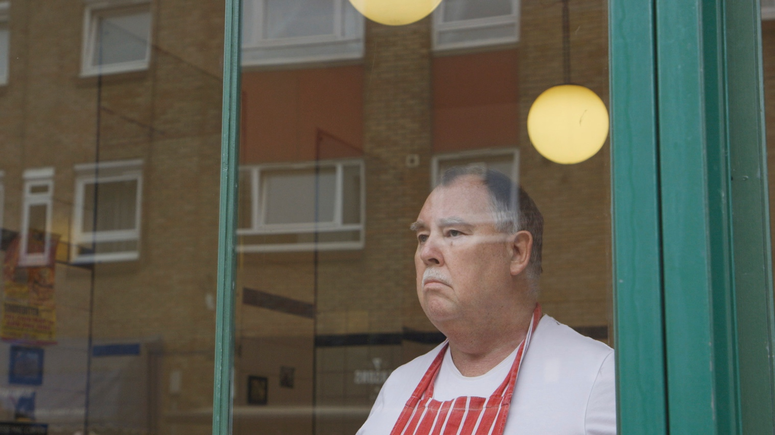

For all publicity enquiries please contact:
keeley@emfoundation.com
Certificate: tbc / Running time: 94 minutes

LOGLINE
Hoxton Street stars in Zed Nelson’s debut feature: a film about love and loss, and a community unravelled by gentrification.

SHORT SYNOPSIS
Focusing on one street in East London and its inhabitants over a four-year period, Zed Nelson’s debut feature charts the toxic collision of gentrification, austerity and the nation’s slide into Brexit.

LONG SYNOPSIS
As the glinting steel and mirror-glass skyscrapers of London’s financial hub edge ever closer, the area surrounding Hoxton Street has been transformed by ‘luxury’ redevelopments and sky-high property prices. This traditional East London street, less than a mile from the City of London, has become the last bastion of the areas disadvantaged – a concentration of the aged, poor and dispossessed.

Hoxton Street’s close-knit working-class community has absorbed waves of immigrants since the 1950’s. But as traditional industry has withered, the latest influx of young urban hipsters followed closely by expensive restaurants, digital media start-ups and corporate property developers has brought with it a deepening social and financial divide.

Sensing they have been left behind, the street’s ageing white residents lament the loss of their jobs and former ways of life, echoing the 52% who voted to leave the EU. Set against rapid gentrification, years of austerity and the eruption of Brexit, Zed Nelson’s feature-length debut is a comic, tragic and deeply moving portrait of not just a street, but a nation on the cusp of enormous change.
DIRECTORS STATEMENT
I began filming in August 2015, at a time of runaway property prices. My aim was to show the anatomy of gentrification as it happens, and its effect on a community. Six months later, then Prime Minister David Cameron announced the Referendum on UK membership of the EU. It proved to be an incredible mistake, splitting the country and exposing deep fault-lines.
The economic priorities of the past three decades have supported free-market values and self-interest. Staggering inequality between the rich and poor has bred resentment at the political and economic establishment. The world’s super-rich now hold the greatest concentration of wealth for 120 years, many of them taking elaborate steps to avoid tax in the process.
In the wake the financial crisis the government made £30 billion cuts from social services since 2010. For councils like Hackney it meant cuts of up to 50% of their annual budget. At the same time, London boroughs have seen rapid gentrification, as land and property prices reached unprecedented levels. While house prices increased exponentially, the number of council homes has been depleted, with only 2 million council homes left in Britain – reduced from 6.5 million in 1980
The film reveals the break-up of community, rapacious commercial development, and the manifestation of Brexit as a result of people feeling left out of the changes happening around them. But while people ‘want their country back’ - lamenting the loss of jobs and community - the film avoids rose-tinted nostalgia, reminding us that pre-EU member Britain was also a place of casual racism.
Blaming the EU was a misdiagnosis of a chronic ailment, which has its roots in Thatcher-era deindustrialisation, a failure to manage the effects of globalisation on wages, and a demand for public services and affordable housing. There are many positives to gradual improvement. But the consequences of the rate and scale of change, the displacement of poor by rich, the loss of workspace and the hollowing out of neighbourhoods by investors, is now frightening even the most ardent promoters of trickle-down regeneration.
--------------
I was born in Uganda, but from the age of three Hackney has been my home.
I went to a forward-thinking experimental primary school in East London that encouraged art and independent thought, until my parents, as 70’s hippies, plucked me out of school and took me and my sister on a one-year road trip to India, travelling overland from Britain in a diesel truck.
When we returned I had the misfortune of ending up at an extremely rough comprehensive school. I found out years later that it had the worst academic record of any school in the capital and in subsequent years was closed down. It was set on a concrete landscape encircled by housing estates and chain-link fences: it was not a place of learning but more a place of survival.
Over the next few years I pierced my ears, shaved my head into a mohican, got a tattoo, was arrested for smoking dope, took acid in Abney Park cemetery and buzzed around the streets in a motorbike gang. We were hardly Hells Angels though; we were so young that we were restricted to 100cc motorcycles with learner plates.
Most of the time it was harmless fun, but it soon turned dark. One friend became addicted to heroin and was murdered in a squat, another was badly injured in a motorbike accident, and another sent to jail for GBH after a fight got out of hand. I had become the product of a bad inner-city education, with the kind of friends that go with it.
At the age of 18, photography gave me a passport back to civilization, and the minute I started college I realised there was so much more to do. I have since travelled widely through my photographic work but remained living in Hackney and am watching with fascination as the area goes through a metamorphosis.
Zed Nelson
QUOTES FROM THE FILM

The Opening Text
“Hoxton Street is a traditionally working-class street in Hackney, one of London’s poorest boroughs.
As property prices reached unprecedented levels in the capital, the government’s austerity programme cut £30 billion from social services across the UK in the nine years starting in 2010.
At a time of growing social polarisation and widespread mistrust of the political establishment, David Cameron announced the EU Referendum.”
--------------

The Priest
“Housing is the big social problem, because the poor people are getting pushed out.”
“The church made this rule that everyone from the Arch Bishop of Canterbury downwards has to retire when they’re 70. I have to retire next year, so I have nowhere to live, it’s just simple money…I just cannot afford to stay in London. Families are getting spread out, and that’s what families are doing: you’re going to have to move to where you can afford to live, and the idea of being born and living and dying in the same area as if it were a little enclosed village - those days have long gone. The strain and pressure on housing associations and local authorities is immense, it’s an absolutely no-win situation. There’s a stronger and stronger and stronger anti-immigration feeling, and it is a huge problem. When you have people on the list for council housing and they’re gradually going up the list near the top and they get offered to go and look at a place, and then suddenly that place has been given to a newly arrived family form somewhere else, the hatred and resentment is enormous, bitter, and deep. And one day it will explode.”
“My motivation as a priest is not based on love, it is based on anger. When I see someone who has to sleep on the stones outside, I’m angry - not at them, but I’m angry that such a thing could happen to them.”
--------------

The Estate Agent
“Who controls gentrification? How do we control it? There’s got to be a social policy. I mean with gentrification really as a business of course it’s going to amplify and increase my business, there’s no doubt about it, but I think this is really an issue which should be looked at by government, otherwise market forces will gentrify everything.
You know there is an issue…politicians have to recognise there is an issue where old established communities are now being almost run out of those localities where they’ve been living for generations. I mean what protections are there? What is their policy?”
--------------

The Ex-City Trader who bought a former Warehouse
“There wasn’t change for a long time, and then a lot of change took place very quickly. Artists, bankers, came along and saw these amazing warehouse buildings, these big Victorian industrial buildings, realised they could get live-work permission on these things but never intended to work there, so they weren’t creating any jobs, they just turned them into warehouse apartments. But it takes that sort of policy which Hackney never had, to maintain control of a rampant gentrification.”
--------------

The Art Gallery Owner
“Aviva has bought up most of Hoxton Square. Mono-culture can’t be right, other things die…the little more interesting things just disappear and die. But it’s true, where artist’s go the corporates will follow.”

FILMMAKER

Zed Nelson – Director & Producer
Zed Nelson is an internationally renowned photographer whose work has been recognised by numerous awards, exhibited in solo shows word-wide, and is in the permanent collections of the Victoria and Albert Museum and the National Portrait Gallery.
Nelson’s recent film, ‘Gun Nation’ (30 mins, 2016) explores America’s deadly love affair with the gun, returning to characters he had met and photographed 18 years previously for his seminal photography book of the same name. The film was commissioned to launch the Guardians online documentary strand, with the support of the Bertha Foundation. The film was short-listed for an RTS award.
Nelson’s short films, ‘Marmite & Fruitcakes’ (about UKIP) and ‘Screenagers’ (about video game addiction), were commissioned by Channel 4 and screened in March & October 2015.
Nelson’s film, ‘Europe’s immigration Disaster’, drew attention to the plight of migrants attempting to make the perilous journey across the Mediterranean Sea to Europe, before the issue became international news. It was commissioned by Channel 4’s Dispatches and screened on British TV in 2014.
Nelson’s first documentary film, ‘Shelter in Place’, exposed systematic environmental abuse by the petro-chemical industry in Texas. The film received a Ch4/Britdoc award and was shortlisted for the ‘Best Newcomer’ Grierson Award.
--------------
Nelson’s book, Love Me, reflects on the cultural and commercial forces that drive a global obsession with youth and beauty. The project explores how a new form of globalization is taking place, where an increasingly narrow Western beauty ideal is being exported around the world like a crude universal brand. Love Me was nominated for the Deutsche Börse Photography Prize and has toured internationally as a solo exhibition.
Nelson’s seminal project Gun Nation was awarded five major international photography prizes and published as a book of the same name. The project explores the paradox of why America's most potent symbol of freedom is also one of its greatest killers. Gun Nation won First Prize in the World Press Photo Competition, the Alfred Eisenstaedt Award, and the Visa d’Or, France.
--------------
Though born in Uganda, East Africa, Zed Nelson has lived in Hackney for most of his life. In his youth it represented a place to get away from. But today, Hackney has become one of London’s trendiest boroughs - undergoing a process of rapid change, regeneration and gentrification.
Nelson’s work on Hackney has been published as a photographic book called ‘A Portrait of Hackney’ in 2014. Nelson explains, “The work reflects on the extraordinary contemporary social situation in Hackney, where fashionable young hipsters, yuppie developments and organic café’s co-exist awkwardly with Hackney’s most under-privileged.” The book is a reflection on the beauty and ugliness that co-exist in the area of London that Nelson grew up in, at a time of change and gentrification.

DIRECTED, PRODUCED and FILMED by
Zed Nelson
WITH SUPPORT from
Alcea Foundation
Museum of London
Arts Council England

EXECUTIVE PRODUCED by
Christopher Hird
EDITED by
Julian Rodd
‘HACKNEY MARSHES SCENES’ CO-DIRECTED by
Pinny Grylls
MUSIC by
Rachel Portman
SOUND DESIGN by
Markus Moll

