REAL

A film by Aki Omoshaybi

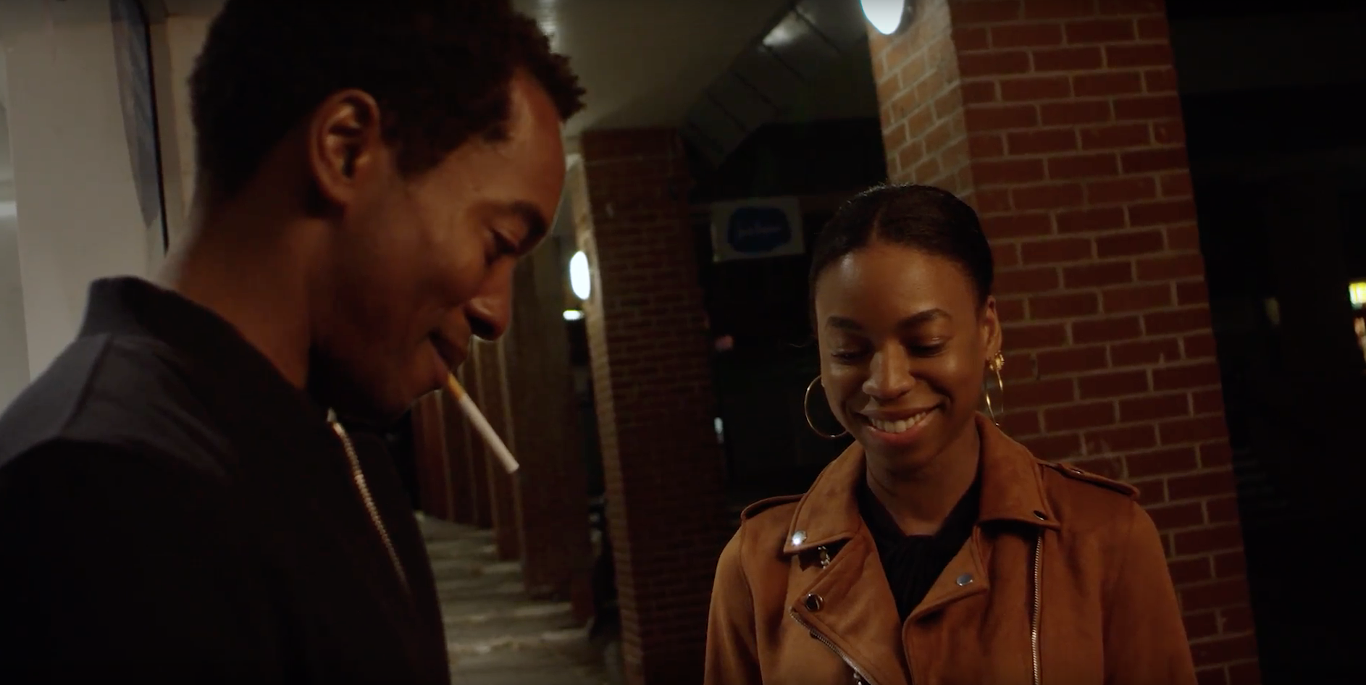

For all publicity enquiries please contact:
keeley@emfoundation.com
Certificate: tbc / Running time: 76 minutes

LOGLINE
Two twenty-somethings navigate their past struggles and growing feelings for one another in this intimate relationship drama from writer-director Aki Omoshaybi.

SHORT SYNOPSIS
An unremarkable newsagent’s sits between a courthouse and a business centre. It’s here that sparks fly between well-dressed Kyle and the equally poised Jamie. Yet despite their composed outward appearances, both are struggling to move from hardships they’d rather keep hidden. As their feelings for one another blossom these difficult pasts resurface, threatening their relationship before it has really even begun.

LONG SYNOPSIS
In inner city Portsmouth, an unremarkable newsagent’s sits between a courthouse and a business centre. It’s here that sparks fly between well-dressed Kyle (Aki Omoshaybi) and equally poised Jamie (Pippa Bennett-Warner). Yet despite their outward appearances, both are struggling to move on from hardship they’d rather keep hidden. As their feelings for one another blossom, their pasts resurface, threatening to break them apart before their relationship has even begun.
An authentic and touching love story from a place where second chances are hard to come by, this impressive debut feature marks actor turned writer-director Aki Omoshaybi as a talent to watch.

DIRECTORS STATEMENT
I wanted to try and make an authentic film about how people navigate through the world of dating when they’re struggling to make ends meet. We mostly see romantic stories from an upper class/middle class perspective: big town houses in London, posh accents, floppy hair. So I thought ‘let’s tip that on its head’ and write something as authentic as possible, something that I’ve seen or could relate to. So I started writing REAL.
I wanted it to be an honest portrayal of a start of a relationship, when we only show what we want the person we’re dating to see. But as we progress the inevitable happens. We fall deeper. We open up more. And the closer we get, a different side emerges - especially when vulnerability is in the mix.
I wanted to shoot REAL in a different landscape to London to show that quite a lot of the country are living in different circumstances to what we see on screen. Life still goes on in places where there’s not been investment in the area for so long, where there’s not a fancy bar or restaurant on every corner, and even if there was, no local would ever have enough the money to go.
I also wanted to make a film with two black protagonists where race and violence weren’t the main calling cards. I wanted to show them not just as humans living everyday life, but the struggles that come with that - something which happens very rarely for black people in British Cinema.
A simple story with complicated layers, when it came to the shoot I wanted the actors to lift the text off the page and bring this story to life with authenticity. Whatever ever the words meant to them, I told them to bring their truth but just don’t miss the beat/objective of the scene. I also wanted the camera to be a character of its own, with its own personality, so we did the whole shoot handheld, letting the audience watch the story unfold like a fly on the wall.
REAL is an honest look at Kyle and Jamie’s lives and I hope the audience feel a part of that journey.
Aki Omoshaybi

CAST

Pippa Bennett-Warner - Jamie
Pippa has just finished shooting GANGS OF LONDON (BBC/HBO) and she can currently be seen in MOTHERFATHERSON (BBC) and HARLOTS (Hulu/ITV). Last year she filmed independent feature WAKEFIELD alongside Bryan Cranston and Jennifer Garner, as well as new Jackie Chan movie THE FOREIGNER. Pippa will next be seen in new Sky Atlantic series SICK NOTE opposite Rupert Grint. Other television credits include THE SMOKE, THE SECRET, THE TRIALS OF JIMMY ROSE and RIVER. Pippa is also an accomplished theatre actress having played in numerous productions at the Donmar Warehouse and National Theatre.

Aki Omoshaybi - Kyle
Aki started in the West End doing plays such as ‘West Side Story’, ‘Hairspray’, ‘Hair’, ‘Umbrellas of Cherbourg’ and ‘Chariots of Fire’, as well as working with the RSC and Royal Exchange. His recent film credits BURNING MEN, which was released in cinema this year, and FACES, for which he is nominated for best actor at the British Urban Film Festival. His other film credits include STAR WARS: THE LAST JEDI, A MOVING IMAGE and THE RIOT CLUB. His most recent TV credits are DEFENDING THE GUILTY (BBC), SICK OF IT (SKY), DOCTOR WHO: Rosa (BBC).

Karen Bryson - Bola
Karen is probably best known for playing Avril Powell in Channel 4’s critically acclaimed drama series SHAMELESS, a role which saw Karen nominated for several awards. She can be seen in Harlan Coben’s thriller SAFE (Netflix) and recently graced the UK screens in MOTHERFATHERSON (BBC) starring Richard Gere. She recently finished filming series regular in Nordic Drama series THE WHITE WALL, from the same team behind ‘The Bridge’ which will be out next year, and has also just wrapped on BULLET PROOF 2 for Sky.

Amy Manson - Trish
Amy Manson is a Scottish actress who recently started shooting Josh Wheedon’s THE NEVERS for HBO. She can was recently seen in BEATS, as well as Scott Graham’s third feature RUN and DOOM 2 for Universal. Her film EDIE, alongside Sheila Hancock, was at Edinburgh Film Festival 2017. Amy’s TV credits in appearing as ‘Cathy Gordon’ in THE WHITE PRINCESS (Starz), ‘Merida’ in ONCE UPON A TIME (ABC), ‘Medea’ in ATLANTIS (ABC), DESPERATE ROMANTICS, BEING HUMAN and OUTCASTS (all BBC). She is also known for her stage work, and is twice winner of the Critics’ Award for Theatre in Scotland for Best Female Performer.

Kola Bokinni - Micah
Rising star Kola Bokinni has most recently appeared in Netflix’s TOP BOY. He film credits include VS for BBC Films, AMERICAN ASSASSIN alongside Dylan O’Brien, HUNTER KILLER with Gerard Butler, ANNIHILATION (Netflix), TWO PIGEONS, WAR MACHINE and 100 STREETS. His TV credits include BLACK MIRROR (Netflix) and CRIMS (BBC).

FILMMAKERS

Aki Omoshaybi – Writer, Director, Producer
Aki predominantly works as an actor across film, television and theatre – REAL is Aki’s debut feature as a writer, director and producer. He has previously made a short film called SPILT - nominated at the British Urban Film Festival and The Groucho Film Festival - back in 2016, which he also wrote, directed, produced and acted in and set up his production company Small Long Productions to make REAL. He is currently writing his second feature CUBS and has a slate of projects with Small Long Productions which he is working on.

Luis Almau - Composer
Luis Almau is an award-winning composer, producer and multi-instrumentalist based in London. Last year he scored THE FLIP SIDE, a 20th Century Fox feature film directed by Marion Pilowsky and starring Eddy Izzard, and more recently WALE, a short film by Barnaby Blackburn which was Oscar shortlisted and BAFTA-nominated. His score for the latter was nominated for a Music and Sound award. Luis has also worked with Nick Cave and Warren Ellis on the recording of ‘All the Gold in California’, which featured in TRUE DETECTIVE (HBO) and engineered Mica Levi’s BAFTA-nominated score for UNDER THE SKIN, directed by Jonathan Glazer. As well as his work on film and TV, Luis’ wide ranging output has seen him score commercials by Michel Gondry and Cary Fukunaga, as well as producing music for artists such as Yazoo.

Small Long Productions
We’ve all heard of the phrase ‘Big Short’ - getting in big and pull out quick to make a quick buck.
‘Small Long’ is the opposite of that - it’s about investing for the long term, longevity. We want to make independent films that have longevity. We want to tell stories that have a lasting effect and keep giving back.

WRITTEN and DIRECTED by
Aki Omoshaybi
STORY by
Aki Omoshaybi & Paulette Mbassa
CAST
Aki Omoshaybi as KYLE
Pippa Bennett-Warner as JAMIE
Karen Bryson as BOLA
Amy Manson as TASH
Kola Bokinni as MICAH
Amanda Lawrence as MONIQUE
EXECUTIVE PRODUCED by
Nick Bryan
Aki Omoshaybi
CO-PRODUCED by
Tori Butler-Hart
Matt Butler-Hart
MUSIC by
Patrik Andrén
DIRECTOR OF PHOTOGRAPHY
Michael Edo Keane
EDITOR
Rebecca Lloyd
PRODUCTION DESIGNER
Sophia Stocco
PRODUCTION DESIGNER
Gaya Yaramyshyan
MAKE-UP DESIGNER
Rebecca Kennell

