MAKING NOISE QUIETLY
Three Conversations
Directed by Dominic Dromgoole
From a play by Robert Holman
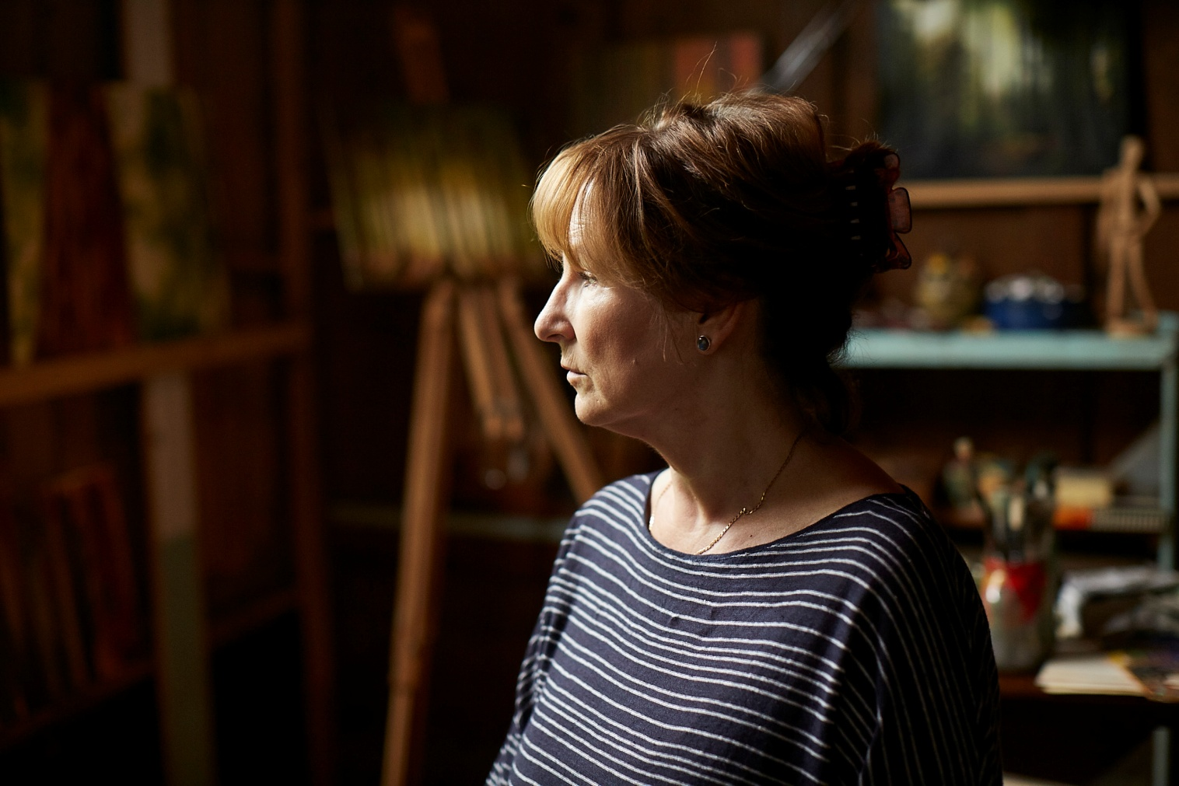

For all press enquiries please contact:
Nicki Foster, Simon Bell, Harriet Gilholm at Premier
T: + 44 20 7292 8330 E: firstname.surname@premiercomms.com
Certificate: tbc / Running time: 93 minutes

LOGLINE
Adapted from Robert Holman’s acclaimed play of the same name, strangers meet for conversations on the edge of three different wars.

SHORT SYNOPSIS
In 1944 in Kent, a conscientious objector (Luke Thompson) and a roaming artist (Matthew Tennyson) find friendship as the Second World War unfolds across the English Channel.

In 1982 in Redcar, a bereaved mother (Barbara Marten) struggles with the memories of her son, lost in the Falklands War.

In 1996, deep in the Black Forest, a holocaust survivor (Deborah Findlay) seeks to bring peace to a disturbed young boy (Orton O’Brien) and his violent stepfather (Trystan Gravelle).

Accompanied by a stunning score from Academy Award winner Stephen Warbeck, director Dominic Dromgoole’s adaptation of Robert Holman’s classic play is a moving study of the effects of war and the scars left behind.

LONG SYNOPSIS
The debut feature from acclaimed theatre director Dominic Dromgoole, Making Noise Quietly is a triptych of encounters, set beneath the shadow of war.

The first story, BEING FRIENDS, is set at Oxen Hoath, Kent, in July 1944. Two young men meet by chance in a field and spend the afternoon together, as doodlebugs fly overhead. Oliver Bell (Luke Thompson) is a conscientious objector, spending the war working on a farm; Eric Faber (Matthew Tennyson) is a wandering artist and writer, uninhibited in his homosexuality. As they discuss the war and its morality, an intense bond forms.

The second story, LOST, is set in Redcar, Cleveland in June 1982. Geoffrey Church (Geoffrey Streatfeild), a young naval lieutenant, visits the home of May Appleton (Barbara Marten), and finds himself having to inform her that her son Ian has been killed in action in the Falklands war. The bereaved mother struggles with bitterness and love as she recollects her estranged son.

The third story, MAKING NOISE QUIETLY, is set in the Black Forest in August 1996. Helene Ensslin (Deborah Findlay), a German Jewish woman and concentration camp survivor, plays host to a brutish and fugitive British private, Alan Tadd (Trystan Gravelle), and his disturbed stepson, Sam (Orton O’Brien). Traumatized by his experiences in the Iraq War and abandoned by his wife, Alan expresses his anger and bitterness by beating Sam. The traumatized boy now communicates only with savage screeches. Helene tries to break their cycle of anger and abuse.

With a stunning piano score, written and performed from Academy Award winner Stephen Warbeck, and break out performances by some of Britain’s finest acting talent, this evocative adaptation of Robert Holman’s celebrated play is a moving look at war and the broken lives left behind.

DIRECTORS STATEMENT
Making Noise Quietly is a contemporary classic, which has long been crying out for cinematic treatment. It tells three stories of meetings between strangers, each happening on the edge of conflict.

The backdrop for each is alive with filmic possibilities: the lush beauty of the Kent weald in 1944 reminiscent of Powell and Pressberger’s A Canterbury Tale; the enclosed front room in Redcar in 1982 invoking memories of Terence Davies; and the claustrophobic expanse of the Black Forest.

These landscapes, and the stories’ capacity to allow insight into the characters’ privacy, make for films that seem small but have an expansive resonance – chamber epics.

It was a privilege to make these films with six of my favourite actors, whose virtues of skill, subtle observation, truth and imagination exemplify the best in our acting tradition.

Dominic Dromgoole

CAST

MATTHEW TENNYSON - ERIC FABER
Matthew reprised the role of Eric from the 2012 stage production of MAKING NOISE QUIETLY at the Donmar Warehouse. For the performance Matthew won the Evening Standard Theatre Award for Best Newcomer. Later that year he won the Best Newcomer award at the Manchester Evening News Theatre Awards for his performance in BEAUTIFUL THING at the Royal Exchange. Further stage credits include the roles of Puck in in A MIDSUMMER NIGHT’S DREAM at Shakespeare’s Globe and Konstantin in THE SEAGULL at Regent’s Park Open Air Theatre. He has just played the lead in A MONSTER CALLS at the Old Vic.

LUKE THOMPSON - OLIVER BELL
Luke Thompson made his stage debut in 2013 as Lysander in A MIDSUMMER NIGHT’S DREAM at Shakespeare’s Globe. He went on to perform as Mark Antony in JULIUS CAESAR. He played James in TIGER COUNTRY at the Hampstead Theatre: Orestes in ORESTEIA and Laertes in HAMLET at the Almeida Theatre.

On screen Luke is known for playing Simon in IN THE CLUB, Joshua Hollows in THE SUSPICIONS OF MR WHICHER and recently as Conor in KISS ME FIRST. His recent film credits include HELLENES by Phaedra Films (2016) and DUNKIRK by Warner Bros (2016).

BARBARA MARTEN – MAY APPLETON
Barbara’s film credits include playing Mary in ORANGES AND SUNSHINE, performing alongside Emily Watson and Aisling Loftus, as well as roles in A PASSIONATE WOMAN*, MOTHER MINE, and THE COLOUR OF LIGHT. Her television work includes VERA, THE ROYAL, and WAKING THE DEAD. She has recently appeared as Hannah Greg in the Chanel 4 period drama THE MILL.

Her stage work includes PEOPLE PLACES & THINGS at the National Theatre; KING JOHN, GABRIEL, HENRY IV, BEDLAM and THE BIBLE at Shakespeare’s Globe.

GEOFFREY STREATFEILD - GEOFFREY CHURCH
Geoffrey’s film work includes the parts of Alan Sinclair in Woody Allen’s MATCHPOINT opposite Scarlett Johansson and Jonathan Rhys Meyers, Sebastian in ANGEL, Peter Hunt in RUSH, and Calum Reed in MI-5 opposite Kit Harrington. He has also appeared in a number of television series including SPOOKS, THE THICK OF IT and he played Edward IV in the award winning drama THE HOLLOW CROWN.

Some of Geoffrey’s stage credits include MY NIGHT WITH REG at the Donmar Warehouse and in the West End, THE BEAUX STRATAGEM at the National Theatre and WILD HONEY at the Hampstead Theatre as well as many productions at the RSC.

DEBORAH FINDLAY - HELENE ENSSLIN
Deborah’s many film credits include ME WITHOUT YOU (Fireworks Pictures), HAMPSTEAD (Ecosse Films), SUITE FRANCAISE (Alliance Films), THE LADY IN THE VAN (Van Productions Ltd), and the Oscar-nominated JACKIE (Fabula).

For her stage work Deborah won an OBIE for her role in the original production of TOP GIRLS by Caryl Churchill. She received an Olivier for her role as Hilda in STANLEY at the National Theatre and was further nominated for her role in THE CUT at the Donmar Warehouse. She has recently starred in the popular BBC series, THE SPLIT.

TRYSTAN GRAVELLE - ALAN TADD
Trystan is best known for his television role as Victor Colleano in ITV drama MR SELFRIDGE. He was selected as one of the Screen International's Stars of Tomorrow in 2012 and further television credits include sci-fi drama UTOPIA, drama NATIONAL TREASURE and this year the AMC drama THE TERROR.

Trystan recently played Clifford in Michael Pearce’s popular BEAST. Some of his other film credits include playing Christopher Marlowe in ANONYMOUS, and Matthew in ONE CHANCE. On stage Trystan has performed for a number of shows as part of the Royal Shakespeare Company. He was nominated for “Best Solo Performance” at the Edinburgh Fringe Festival for his role as Dave in HONEST at the Soho Theatre.

ORTON O’BRIEN - SAM
Orton has been training with The Television Workshop in Nottingham for two years. He can currently be seen in the Disney feature CHRISTOPHER ROBIN where he plays the role of Young Christopher Robin. He played Young Sam in The Television Workshop's original production of HEADWRECK in 2016 as well as recently appearing in an NSPCC campaign about online safety for young people. Orton is a massive Star Wars fan, loves to draw and takes a great interest in history and current affairs.

FILMMAKERS

DOMINIC DROMGOOLE - DIRECTOR
Dominic Dromgoole has worked extensively in theatre around the world and was artistic director of The Globe from 2006-2016. In that time, he mounted over a hundred productions including thirty new plays, and redefined the theatre as a centre of radical scope and ambition. Dominic and his team created a national touring circuit, and an international network, which brought productions from 40 different countries to the Globe, and from the Globe to every country in the world. He also planned and built the Globe’s new indoor theatre, the Wanamaker Playhouse. It was at the Globe that he gained his first taste for film production after developing a video-on-demand platform for Globe productions, and making and showing 37 short films, celebrating Shakespeare’s plays in their real settings.

Previous to The Globe Dominic worked as Artistic Director at The Bush from 1990-96. He was in charge of new plays with Sir Peter Hall’s company at the Old Vic in 1997, and ran the Oxford Stage Company from 1999 to 2005. He has written many essays for the Sunday Times, The Guardian and the Telegraph; has worked as a columnist for the New Statesman and the Guardian, and has written three books, The Full Room, Will & Me and Hamlet: Globe to Globe.

Since leaving the Globe, Dominic’s theatre company Classic Spring has produced the critically acclaimed Oscar Wilde Season at the Vaudeville theatre in 2017/18. In 2016 Dominic set up Open Palm Films with the remit of creating small budget chamber
epics. So far he has produced five films for the company: Making Noise Quietly, which he also directed, Pond Life, Undercliffe, Tides and Benjamin.

ROBERT HOLMAN - SCREENWRITER
Robert Holman wrote the original three short plays MAKING NOISE QUIETLY and is a renowned and celebrated playwright in British Theatre. He has spent periods as resident dramatist with the National Theatre and with the Royal Shakespeare Company in Stratford-upon-Avon.

His plays, including JONAH AND OTTO, THE NATURAL CAUSE, GERMAN SKERRIES (for which he won the George Devine Award), OTHER WORLDS, TODAY, ACROSS OKA, RAFTS AND DREAMS, BAD WEATHER, and HOLES IN THE SKIN have been seen in cities as far apart as Los Angeles and Tokyo, following their premieres at such theatres as the Royal Court, the Bush, the RSC, Manchester Royal Exchange and Chichester Festival Theatre. He has also written a novel, THE ALMISH LANDSCAPE. His recent play A BREAKFAST OF EELS premiered at the Print Room in 2015, where it won the Off West End Theatre Award for Best New Play. He has also written episode screenplays for television series, including PLAY FOR TODAY and SECOND CITY FIRSTS.

NICK DRAKE - SCREENWRITER
Nick was Literary Manager at the Bush Theatre from 1990-1994, and then Head of Development at Intermedia Films until 2002, overseeing the creative development of projects including the Oscar nominated HILARY AND JACKIE, ENIGMA, IRIS, SLIDING DOORS, THE QUIET AMERICAN, and THE GIRL WITH THE PEARL EARRING. He was a Literary Associate at the National Theatre from 2004 to 2006.

Nick adapted the acclaimed memoir ROMULUS MY FATHER by Raimond Gaita as a feature film for Arena Films in Australia, directed by Richard Roxburgh and starring Eric Bana and Franka Potente. The screenplay was nominated for best screenplay, and the film won Best Feature, and many other awards, at the Australian Film Institute Awards. Nick is currently adapting WHITE MUGHALS by William Dalrymple for Rainmark Films, with Ralph Fiennes attached to direct.

Nick’s other recent projects include THE TIME IS NOW for producer Dan Lupovitz, SILENT LAND, co-written with James Marsh, and BAGHDAD WEDDING, based on the play of the same name, both for Focus Features. Nick is currently writing SECOND BEST BED for Ecosse Films and new films for Pathe and See-Saw.

MARK ROSENBLATT - SCREENWRITER
Mark Rosenblatt is the Associate Artist at the West Yorkshire Playhouse and a freelance director. From 2011 to 2013, Mark was the Associate at the National Theatre Studio. Prior to that, he ran Dumbfounded Theatre from 2001. In 1999 he won the JMK Award for Young Directors and now serves as the JMK Trust’s Vice-Chair.

Mark directed and wrote the screenplays for both Antony and Cleopatra (2016) and Henry VIII (2016), produced by Shakespeare’s Globe and the BFI for The Complete Walk. He also wrote the screenplays for THE CONSTANT WIFE (2008/10) and THE CIRCLE, both adapted from plays by W. Somerset Maugham and to be produced by Brilliant Films. His recent work as director includes UNCLE VANYA (2015), RICHARD III (2015), VILLETTE (2016) and THE FRUIT TRILOGY (2016).

STEPHEN WARBECK - COMPOSER
Stephen Warbeck is an Academy Award-winning English composer best known for his film scores, which notably include SHAKESPEARE IN LOVE, BILLY ELLIOT and THE OTHER MAN. He has been a significant creative presence in British cinema for several decades, and is one of the best-known film composers working today. His film scores can most recently be heard in Richard Eyre’s THE CHILDREN ACT.

His television credits include Lynda La Plante’s PRIME SUSPECT, for which he received a BAFTA nomination and he recently scored THE DRESSER, starring Ian McKellen and Anthony Hopkins, for the BBC and both series of Channel 4’s prestigious primetime drama INDIAN SUMMERS. He has also written music for numerous theatre productions including WOLF HALL/BRING UP THE BODIES (RSC), THE TEMPEST (The Globe), THIS HOUSE (National Theatre) and productions at the Almeida and the Royal Court. Stephen is a founder member of The Kippers, with which he still regularly performs.

ALEXANDRA BREEDE - PRODUCER
Alexandra is a graduate of the National Film and Television School (NFTS) MA in Producing program, where she produced a number of short films including GROUP B, which was nominated for the Student Academy Award and won the RTS Award for Best Graduate Fiction. Her other films include FULFILAMENT, a stop-motion animation, and PIONEERS, a documentary set in the Mojave Desert. Collectively, these three films have now screened in over 60 film festivals around the world including AFI, TIFF KIDS, Austin, St. Sebastian, Melbourne, Nashville and Cinequest.

In 2014, she began working at the Globe Theatre where she was the associate producer of THE COMPLETE WALK, a collection of 37 short films that has now screened as an installation in over 10 cities around the world, for Dominic Dromgoole.

JACOB THOMAS - PRODUCER
Jacob is an up and coming producer from New Zealand based in London. He graduated with film and law degrees in Auckland and subsequently worked on films, commercials and music videos. He quickly built up experience in a variety of roles in camera, directing and production before deciding to focus on producing. Moving to the UK, Jacob completed a MA at the National Film and Television School.

His short films NORTH, SEA CHILD and TERRITORY won numerous prizes including HotDocs, Galway Film Fleadh, Raindance and a Student Academy Award nomination. Jacob co-produced MAKING NOISE QUIETLY with Alexandra Breede and is currently producing Eva Riley’s first feature PERFECT TEN through the Creative England iFeatures scheme.

OPEN PALM FILMS
Hamlet’s advice is sharp. He warns not to overstep ‘the modesty of nature’. Nature is not bombastic, or sensational, or majestic, nature is itself, and modestly so.

There is an old myth about the word sincerity. Old sculptors used to adulterate the materials they used with wax, and thus a pure piece of sculpture would be stamped ‘sine cera’, without wax. Truthful work is without wax, it is sincere.

Open Palm Films aim to be modest and sincere, to be light and funny, and to celebrate the tender power of truth.

Open Palm Films have made six films thus far, Making Noise Quietly was the first.

DIRECTED by
Dominic Dromgoole

SCREENPLAY by
Robert Holman
Nick Drake
Mark Rosenblatt

Based on the play
Making Noise Quietly‘ by Robert Holman

CAST
‘BEING FRIENDS’
Matthew Tennyson as ERIC FABER
Luke Thompson as OLIVER BELL
Paul Rider as VICAR
Joanne Howarth as MRS WHITTLE
Meg Coombs as TESSA
Trevor Fox as JESSAKIAH
James Lailey as MR WHITTLE
Charles Rides as VICAR’S GRANDSON

‘LOST’
Barbara Marten as MAY APPLETON
Geoffrey Streatfeild as GEOFFREY CHURCH

‘BEING FRIENDS’
Deborah Findlay as HELENE ESSLIN
Orton O’Brien as SAM
Trystan Gravelle as ALAN TADD

PRODUCED by
Alexandra Breede
Jacob Thomas

EXECUTIVE PRODUCER
Mark Coombs

MUSIC COMPSED AND PERFORMED by
Stephen Warbeck

DIRECTOR OF PHOTOGRAPHY
NICK COOKE

EDITOR
Ricardo Saraiva

PRODUCTION DESIGNER
Damien Creagh

COSTUME DESIGNER
Jonathan Fensom

MAKE-UP AND HAIR DESIGNER
Bethany Swan

CASTING DIRECTOR
Andy Morgan CDG

