MARI

A film by Georgia Parris

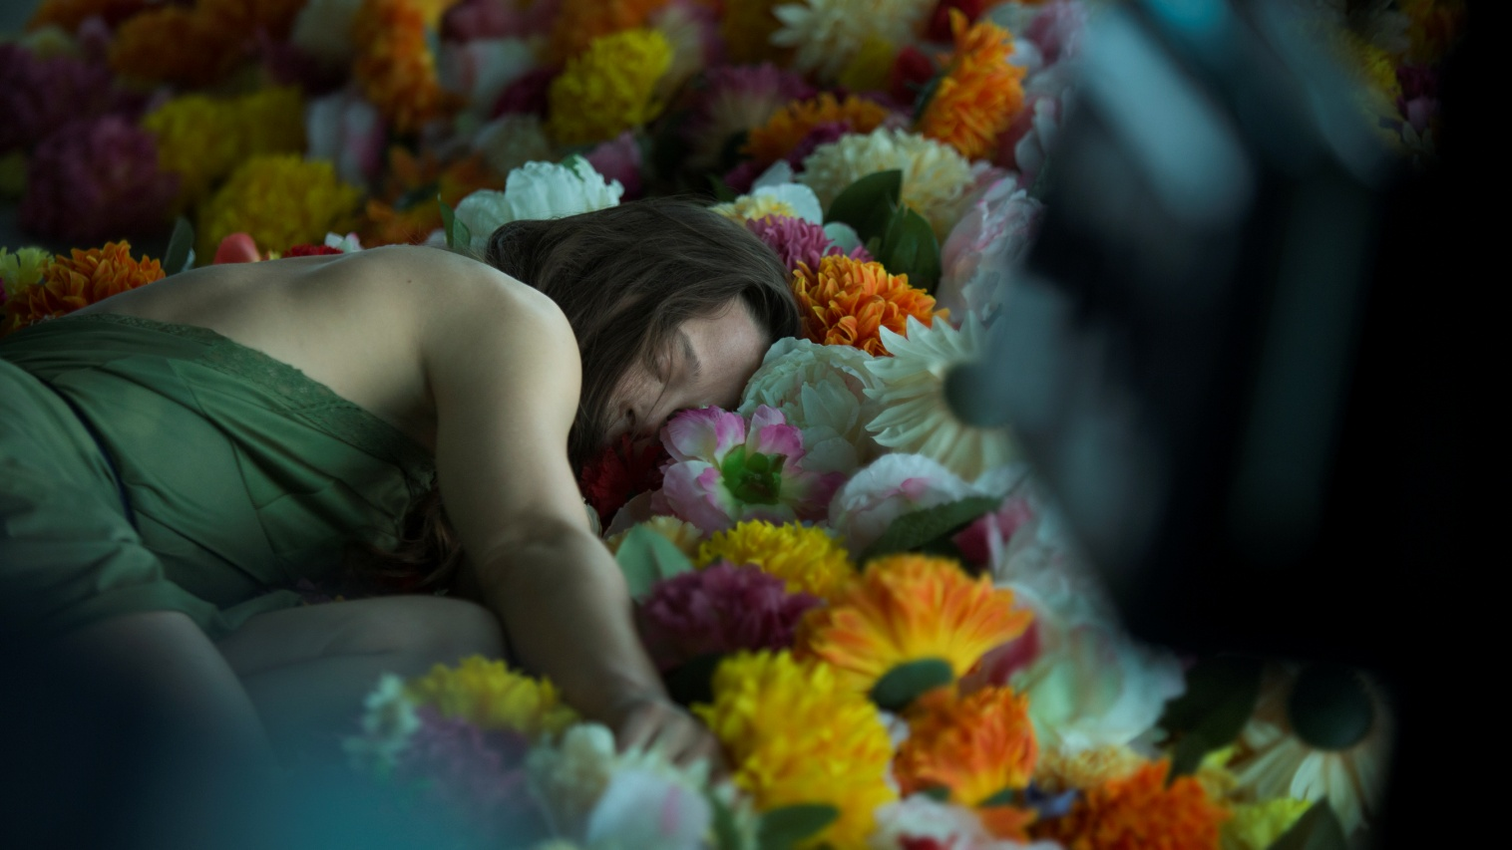

For all publicity enquiries please contact:
keeley@emfoundation.com
Certificate: tbc / Running time: 94 minutes

LOGLINE
Drama, dance and death innovatively collide in Georgia Parris’ life-affirming debut feature starring renowned contemporary dancer Bobbi Jene Smith.

SHORT SYNOPSIS
Professional dancer and choreographer Charlotte (Bobbi Jene Smith) is preparing for a new show. Everything is going well, until she receives a call: Mari, her grandmother, is dying. Putting her life in London temporarily on hold, Charlotte leaves to support her mother and sister, despite the tensions that linger over the family's strained relationships.
Featuring sequences choreographed by Maxine Doyle, and an evocative score by Peter Gregson, Georgia Parris’ genre-defying dance-drama is a love letter to mother-daughter relationships and the difficult choices we make to preserve them.

SYNOPSIS
Charlotte (Bobbi Jene Smith), a successful contemporary dancer, is thriving in London. With her latest show just days away from opening night, she receives news that her grandmother, Mari (Paddy Glynn), is dying. Dropping everything, she heads to Dorset to join her mother (Phoebe Nicholls) and sister (Madeline Worrall), but on arrival she discovers she's unexpectedly pregnant. Initially set on a termination, Charlotte starts to doubt herself as she watches her family contemplate losing their matriarch.
Performed by celebrated contemporary dancer Bobbi Jene Smith in her first dramatic role, dance sequences choreographed by Maxine Doyle (Associate Director and Choreographer for Punchdrunk) are innovatively woven into the film’s narrative to express Charlotte’s interior struggle. All set to an evocative score by classical rising star Peter Gregson, writer-director Georgia Parris’ debut feature is a bold meditation on mortality, motherhood and the unbreakable bond between the two.

DIRECTORS STATEMENT
Mari is an honest and relevant film about women and the choices we make about family and career in an age where we’re told we can and should ‘have it all’. Having used dance in all my films I was excited to expand on its ability to simultaneously convey emotion, character and a strong aesthetic. My vision with Mari was to combine the physicality and innovation of dance with authentic character-driven drama for a unique film experience.

Georgia Parris

CAST

BOBBI JENE SMITH - CHARLOTTE
Bobbi Jene Smith is a renowned contemporary dancer and choreographer, having spent 10 years at the world famous Batsheva dance company in Israel, under the artistic direction of Ohad Naharin. Since leaving the company she has been creating her own critically acclaimed work.
Bobbi is an alumnus of the Juilliard School, North Carolina School of the Arts, and the Royal Winnipeg Ballet School. Her choreography has been presented by The Batsheva Dance Company, PS122 COIL Festival, A.R.T, The Israel Museum, Luminato Festival, The Wild Project, Machol Shalem, Sacramento Ballet, The CCA, and the San Francisco Conservatory of Dance. She has worked in Punchdrunk's production of Sleep No More as well as Dido and Aeneas and Orphic Moment choreographed by Zack Winokur. She is a founding member of A.M.O.C (American Modern Opera Company).
Bobbi’s film and video work include, Annihilation directed by Alex Garland, MA directed by Celia Rowlson-Hall, and Yossi directed by Eytan Fox. The documentary Bobbi Jene which follows Bobbi’s trajectory of leaving Batsheva to create her own work, swept the Tribeca Film Festival, winning best documentary, best cinematography, and best editing in 2017. In 2018 she starred as an actress and dancer in Mari directed by Georgia Parris.
Upcoming projects include new commissions by CORPUS, the dance laboratory of the Royal Danish Ballet, Gibney Dance Company, a collaboration with Maxine Doyle on the Martha Graham Dance Company and choreographing and starring in a feature film directed by Boaz Yakin.

FILMMAKERS

GEORGIA PARRIS - WRITER/DIRECTOR
Georgia is a writer / director based in London. Mari, her debut feature film commissioned through the Film London, BFI & BBC Films' Microwave scheme had its worldwide premiere at the 2018 BFI London Film Festival. Georgia has made a series of award winning short films, specialising in the use of dance as well as putting women’s stories at the forefront of all of her work.
Georgia is currently developing her second feature film with the BFI and the BBC.

EMMA DUFFY - PRODUCER
Emma is a producer based in London. Emma's first feature Mari, directed by Georgia Parris, premiered at the BFI London Film Festival in 2018, and will be released this summer. As well as producing her own projects she has also acted as an executive producer for Wellcome on titles such as Craig Robert's Eternal Beauty starring Sally Hawkins, Girl Untitled by Sarah Gavron and Wildfire, the debut film from Cathy Brady.
She is currently developing her slate, including her second feature with Georgia Parris which is being developed with support from the BFI and BBC Films.

MAXINE DOYLE - CHOREOGRAPHER
Since 2002 she has been Associate Director and Choreographer for Punchdrunk, with whom she co-directed many works including the multi-award winning Sleep No More (London, Boston, New York, Shanghai) and The Drowned Man. Her work for theatre and opera includes Evening at the Talk House (NT) and The Cunning Little Vixen (Glyndebourne). Work for brands includes Luis Vuitton and Selfridges. Recent dance theatre work includes After Lethe for Staastheater Kassel.
Future projects include new work for Martha Graham Dance Company and a site-based dance theatre work creation with Struct Dance, Perth Australia for 2019.

PETER GREGSON - COMPOSER
Peter is a composer and cellist ‘working at the forefront of the new music scene’ (The New Yorker). His latest album, Recomposed by Peter Gregson: Bach – The Cello Suites, was released on Deutsche Grammophon in October 2018. It is a stunning reinterpretation of Bach’s six suites, performed by Gregson and an ensemble of five cellos underpinned by a subtle electronic soundbed.
His debut solo album, Terminal (2010), was commissioned by Bowers & Wilkins and led to his first ballet commission, Hubert Essakow's FLOW at The Print Room, London. Other albums include Lights in the Sky (2014), composed for cello, piano, and analogue synthesisers, TOUCH (2015), released on Sono Luminus and Quartets: One and Quartets: Two (both 2017). The soundtrack to his first feature film, A Little Chaos, directed by Alan Rickman was nominated for the Public Choice award at the World Soundtrack Awards.

WRITTEN and DIRECTED by
Georgia Parris

CAST
Bobbi Jene Smith as CHARLOTTE
Phoebe Nicholls as MARGOT
Madeleine Worrall as LAUREN
Peter Singh as ROHAN
Paddy Glynn as MARI
Will Thompson as RYAN
Nicholas Bruder as JOE
Reuben Kell as BILLY

PRODUCER
Emma Duffy

MUSIC by
Peter Gregson

DIRECTOR OF PHOTOGRAPHY
Adam Scarth

EDITOR
Napoleon Stratogiannakis

PRODUCTION DESIGNER
Bobbie Cousins

COSTUME DESIGNER
Holly Rebecca

MAKE-UP AND HAIR DESIGNER
Bean Ellis

CASTING DIRECTOR
Aisha Bywalters

