

New Town
Utopia

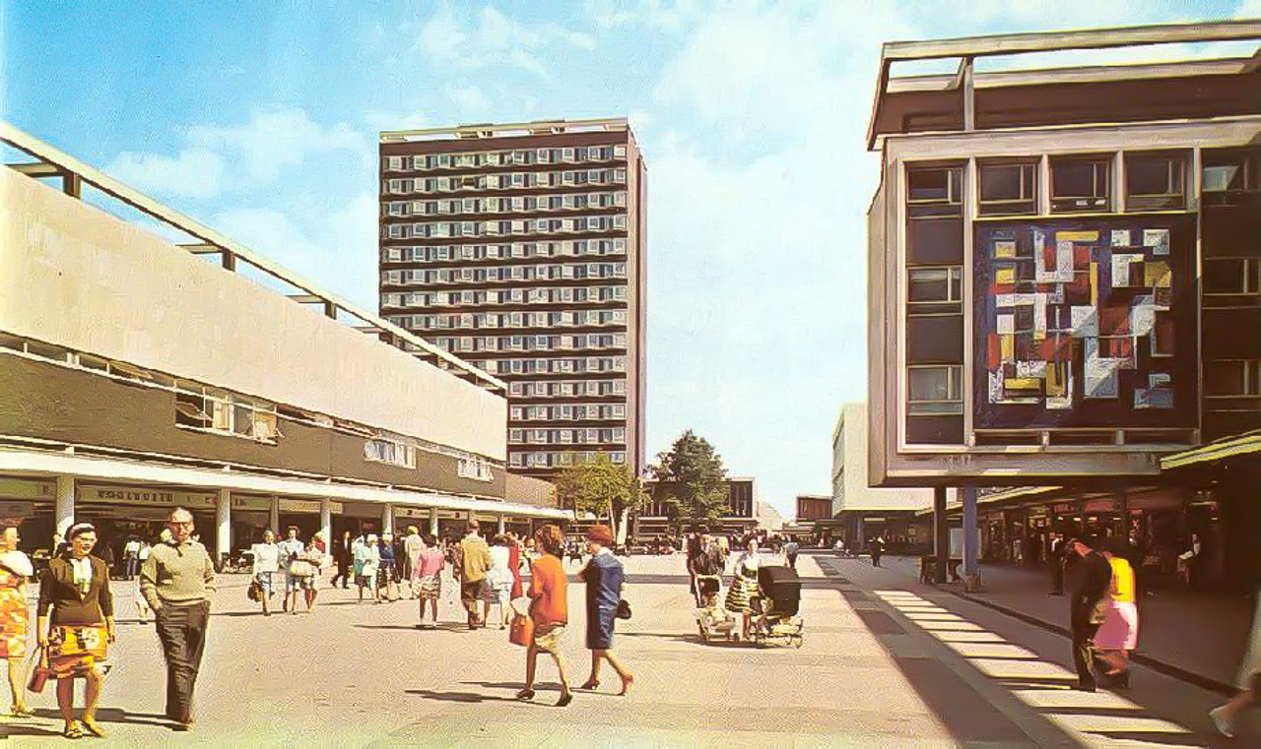

A documentary by Christopher Ian Smith

With Jim Broadbent as the voice of Lewis Silkin MP

For all publicity enquiries please contact: porterfrith@hotmail.com

For press materials: www.vivaverve.com

Certificate: tbc /Running time: 80 minutes

LOG LINE

New Town Utopia is a feature documentary film about utopian dreams and concrete realities. The challenging, funny, and sometimes tragic story of the British new town of Basildon, Essex.

The narrative is guided by the artists, musicians and poets of Basildon – on a journey through memory, place and performance. Facing austerity, adversity and personal battles they are individuals driven by creative spirit to help their community through art, poetry, music… and some rather angry puppets.

SYNOPSIS

New Town Utopia is a feature documentary film about utopian dreams and concrete realities. The challenging, funny, and sometimes tragic story of the British new town of Basildon, Essex.
After WW2, New Towns were designed as social utopias to create (in the words of the post-war government) “a new type of citizen, a healthy, self-respecting, dignified person with a sense of beauty, culture and civic pride.” Basildon and its pioneer residents were invested with these post-war hopes and aspirations. Now, 60 years on, the town has deteriorated, degenerated and desaturated. Art and culture are almost a distant memory and Basildon is often referred to as one of the worst towns in Britain.
The story of Basildon is expressed through the memories of a group of charismatic but often self-destructive artists and musicians who keep ‘creating’ against the odds. Facing austerity, adversity and personal challenges these are individuals driven by their creative spirit to help their community through art, poetry, music… and some rather angry puppets. The film interweaves their music, poetry and art into a narrative that explores the roots of the housing crisis, the impact of demonising the working class and the sucker punch inflicted by globalisation on our towns and high streets.

DIRECTORS STATEMENT

‘Basildon is complicated’, so wrote Norman Scarfe in the 1968 Shell Guide To Essex. He was right.

In 1946, Lewis Silkin, the Minister for Town and Country Planning, delivered a lyrical and impassioned speech to parliament. In the midst the Labour government’s radical post-war policy drive, he announced a plan to build ten ‘new towns’ across the UK. It addressed the major issues facing the cities of Britain - including the devastating impact of WW2 bombing and atrocious living and working conditions - by relocating families to new, purpose-built towns. Silkin’s speech expressed a desire to create ‘a new type of citizen’ who would develop through living in the new town ’a sense of beauty, culture and civic pride’. He evoked Thomas More’s Utopia in the scale of his ambition.

The new towns and their early residents were invested with these post-war hopes and aspirations. Seventy years on, Basildon, one of this first wave of new towns, is a challenging place that’s been through difficult times. According to recent research carried out by its council, Basildon houses one quarter of the most deprived areas in Essex and the gap between rich and poor is huge; making it the 6th most unequal city in the country, with 29% of workers in Basildon earning less than the living wage. Art and culture seem to be a distant memory. Its negative reputation precedes it, having cemented a place in popular culture as a paradigm of a shit British town.

So what happened? This was the question that provoked New Town Utopia, a feature documentary and passion project for me. I grew up in the town next door to Basildon. when I was young I spent a lot of time there with my mum, and it felt different to the rest of the world as I knew it. Odd sculptures floated above the pedestrianised high street. The buildings were concrete boxes that gleamed on sunny afternoons. Buildings that amplified the sombre mood of dark wet days. It also had a brilliant comic book shop.

Growing up in the 80s, a negativity surrounding Basildon seemed to swell and fester, locally something of a no-go location if you weren’t from the town. At a national level names began to stick - Basildon Man, Chav, Essex girl - labels that were sometimes ball and chain, sometimes badge of honour. Unsurprisingly these weren’t coined by people from Basildon or Essex. A Sunday Telegraph article first identified ‘Basildon Man’, defining him as ‘young, industrious, mildly brutish and culturally barren’. It was patronising, superior and fully intended to reinforce negative perceptions of successful working class people.

I returned to the town, decades later, and the fabric didn’t seem all that different, a few cracks here and there. There were new developments and half the pubs were now blocks of flats. Most significantly, large swathes of the the once bustling high street had been replaced by charity shops, betting shops, payday loan lenders and empty shops - like so many high streets across the UK. This local economy has been dispersed and shunted elsewhere, to Amazon, shopping centres and out of town cinemas, restaurants, bars, pubs. The biggest Tesco in Europe on the edge of town.

Basildon has long been a political bellwether - it voted for Thatcher, Blair and then Brexit. With this in mind, I hope that the film, through its focus on one town, reveals something about the state of modern Britain. In the 70s the town began a shift from being a socialist stronghold dubbed “Little Moscow on the Thames” to a Tory stronghold within ten years. This was destabilising change, as the individual trumped community in a town built upon communitarian values, with Thatcher’s ‘right-to-buy policy at its heart. On top of this, the adversarial nature of British politics led to changing parties in power (nationally and locally) pulling the town in different directions, at a time when it was still growing. As Vin Harrop, a champion for the arts in Basildon, once told me ‘democracy does not build new towns’.

Brexit happened two thirds of the way through the heavy-lifting on New Town Utopia, and it was a considered decision not to change direction or retrofit what had come before into a new narrative about Europe. I don’t want this project to be defined by Brexit, however by its nature will offer a perspective on the underlying influences upon the decision of 70% of voters in Basildon, a town with relatively low levels of immigrant residents.

Some of those I met were artists, poets and musicians whose creative pursuits occurred either in spite of the town, or as a reaction against it.. They were individuals with imagination, talent, fight and a shared belief in the positive power of self expression. These characters included: Steve Waters (the puppeteer behind Old Man Stan, a puppet pensioner activist who gained a cult following on YouTube), folk and blues musician the ‘Bard of Basildon’ Phil Burdett, poets Ralph Dartford and Ölmo Lazarus and musicians such as Sue Paget and Rob Marlow from the ‘80s electro scene that spawned bands like Yazoo and Depeche Mode.

Their thoughts, work and memories are the narrative engine of the film of New Town Utopia. That particular line from Silkin’s speech lingered, ‘a sense of beauty, culture and civic pride’. This aesthetic utopian dream felt so alien to the mood of the town, a mood that I gauged through time spent with many Basildon people during my research. Although it’s true that many of the first generation ‘pioneers’ maintained pride about the town, what it represented, and the shelter it provided, I found that many from later generations were desperate to escape, and seemed to blame the town itself for many of their own personal ills.

Somehow, somewhere, over time, Silkin’s aesthetic and civic dream had faltered - in the film I try to understand why and how this happened, and what this means for Basildon, its people and the rest of the UK. In doing this the film touches on some key challenges facing British society, including the housing crisis, the sucker punch of globalisation and new technology on our high streets, and the continued demonisation of people from working class backgrounds.

The style of the film is intended to be at once both objective and immersive, a meditation on place that is part psychogeography and part city symphony. The cinematography is focused on the exterior spaces of the new town. The composition of the landscapes and interviews is influenced by classic architectural photography – most strongly the work of the Bernd and Hilla Becher - an objective eye interlocked the subjective ear of memories, art and ideas. I hoped to immerse the audience in the town’s textures, colours and design, to represent the journeys, sights and aesthetic experience of the town’s residents. Static and slow moving cameras at eye level, through tunnels, over bridges, across parks. The view from a car window.

Camus considered Utopia to be ‘in contradiction to reality’. So Basildon’s not Utopia, but where is?

ABOUT THE TEAM

CHRISTOPHER IAN SMITH – Producer/Director

Chris is a filmmaker and photographer based in London. In his early career he was a DJ/VJ and Producer with the audiovisual collective Addictive TV. He was involved with the production and live performance of many experimental films, audiovisual cut-ups and motion graphics. This included performances and screened work at festivals and venues across the world, including: Le Centre Pompidou, the ICA and the BFI.

Chris is now focused on developing narrative moving image work. His work spans documentary and fiction, sometimes combining the two. Regular thematic strands in his work include the interplay of the human psyche with landscape, folklore, architecture and the uncanny. Chris has created commercial films and creative work for brands including Guinness, O2, Sony PlayStation and the National Lottery

Chris’s films and photography have been screened/exhibited at film, photography and art festivals globally, and he has been selected for a number of film development and talent schemes, including Edinburgh International Film Festival Talent Lab and the FilmLondon Micro Market.

JIM BROADBENT – Narrator

Jim Broadbent studied at LAMDA before launching into a stage career, performing with directors such as Trevor Nunn and Mike Leigh. His first leading role in a film was in Leigh’s Life Is Sweet, further roles followed in Woody Allen’s acclaimed Bullets Over Broadway, Little Voice, in which he starred alongside Michael Caine and as William Gilbert in Topsy Turvy, for which he won a BAFTA award. In 2001 the actor starred in IRIS alongside Judy Dench, in a part that won him both an Academy Award and Golden Globe for best supporting actor.

He then went on to feature in numerous box office hits including Martin Scorsese’s Gangs Of New York, alongside Robert De Niro, Baz Luhrmann’s Moulin Rouge and in Bridget Jones' Diary playing Bridget’s long suffering dad.

Broadbent has also featured in numerous TV series including The Borrowers, Game Of Thrones and War and Peace. One of his most recent film roles is in Paddington 2 reprising his role as Mr Gruber.

MARGARET MATHESON – Executive Producer

Margaret is an experienced Producer and Executive Producer with a distinguished history of independent filmmaking in the UK. She produced seminal British films such as Scum and Made In Britain and more recently SShell and Skin. She was also Executive Producer of Sid and Nancy and Lore. She found success and acclaim with the recent documentary film Sleep Furiously by Gideon Koppel.
Most recently she was Producer of the Bafta award winning children’s television series Katie Morag.

www.bardentertainments.co.uk

GREG HAINES – Composer

Greg Haines is an English composer and musician who’s work exists in the unknown territories of delay-heavy, tape saturated, dub influenced studio sessions, and excursions into modern classical music and more traditional composition. Through his first three albums (recently re-issued together in 3CD or deluxe 5LP format through Denovali Records), Haines delved into long-form, slowly unravelling crescendos for strings, piano and other orchestral instrumentation, all accentuated with subtle electronics and processing to form a wall of sound where each element became indistinguishable.

Haines has toured extensively around Europe, as well as in the USA, Japan and Australia. His brand of live improvisation on his constantly evolving set-up of synthesizers, signal processors and piano led to his involvement with two live ensembles for pure improvisation: the languid, micro-seismic “Alvaret Ensemble” and the adventurous upbeat endeavors of “The Group”.

www.greghaines.wordpress.com

NEIL LENTHALL – Editor

London-based Editor specialising in cinematic Drama and Documentary. Graduate of the National Film and Television School’s MA Editing course. During a decade working in post-production Neil has edited three feature films and a dozen narrative short films; documentaries shot in the UK, France, the Netherlands, and the Faroe Islands; music videos, live music and behind-the-scenes videos for artists signed to Warner Music, Universal Music and Columbia Records; and commercials, web video and corporate comms for a client list that has included the likes of Walkers Crisps, Tesco, Ford, the NHS, the Highways Agency, Tropicana, and the England 2018 World Cup bid.

FEATURING

MARC BARNACLE
SHAUN BADHAM
PENNY BETTERIDGE
TERRY BIRD
STUART BROWN
PHIL BURDETT
RALPH DARTFORD
VIN HARROP
BARRY HAYES
RICHARD HAWKINS
JOE HYMAS
KATH JOYCE-BANKS
PAT JOYCE
OLMO LAZARUS
RICHARD LEE
ROB MARLOW
JOE MORGAN
VINCE O’CONNELL
SUE RYDER PAGET
MIKE PARKER
STEVE WATERS
TIM WILLIAMS
Produced, Filmed and Directed by
CHRISTOPHER IAN SMITH

Executive Producer
MARGARET MATHESON

The voice of Lewis Silkin
JIM BROADBENT

Music
GREG HAINES

Editors
NEIL LENTHALL
CHRISTOPHER IAN SMITH

Edit Assistant
NOEMIE PHILIPPSON

2nd Edit Assistant
SEBASTIANO DELL’EVA

Additional Editing
ED COLTMAN
OANA MARIN RUSU

Colourist
BRENDAN BUCKINGHAM

Sound Design
ROBIN GREEN

Dubbing Mixer
STEVE COOKMAN

Additional Cinematography
PAUL MICHAEL ANGELL
LEWIS DAVIES
FRANCIS QURESHI

Camera Operator
CARLOS CALIKA
JAY LAKER
TOM MARCHBANKS
MATTHEW ROWLEY

Assistant Producers
ANNEKA HASKINS
NATALYA MYKHAYLYUK

Production Assistants
ROXANNA GHIRBOMEAN
GREG HORNER
LUBNA SALAD
LEAH YVONNE REVIVO
PAUL VERNON

Researchers
HIMANSHU SHARMA
WILL ALMOND
SHARON KITS
ANNA KIDEL
KENO KATSUDA
CHRISTY O’NEIL

Marketing Assistants
AMANDA SOON
DAVIDE RAMBALDI

Additional Music
The Face Of Dorian Gray
Written and Performed by ROBERT MARLOW

Additional Footage
Basildon – Our Town
Produced by WOODLANDS SCHOOL
Community
Produced by NEW TOWN FILMS

Archive
KINOLIBRARY
Personal collection STEPHEN BALDWIN
Rant n’ Rave at The Roundacre SANDRA BROWN
Personal collection RITA CLARK
Personal collection DEAN CLARKE
Personal collection DAWN DERRICK
Personal collection PAUL DODD
City 19 at The Towngate DEAN FENNER
Personal collection STEVEN HASTINGS
Personal collection DAVE HAWKINS
Jelly Pinnacle at The Roundacre MARK LANGRIDGE
Land at The Roundacre PAUL PROGRAM
Personal collection IAN ROUGH
Personal collection ROB WOOD

A Cult Modern Production.

Distributed by Verve Pictures

www.vivaverve.com

Artworks featured
Morning by Shaun Badham
Mosaic by GEOFFREY CLARK
Christ by T.B. HUXLEY JONES
Devourer Of Souls by ALAN JOYCE
There’s A Spectre Haunting Europe by ALAN JOYCE
Mother and Child by MAURICE LAMBERT
After The Uprising by ROBERT KOENIG
The Chessmen by WILLIAM MITCHELL
Man Aspires by AJ POOLE
The Compass Bowl by WENDY TAYLOR
Animal Fresco by WENDY TAYLOR
Armillary Sundial by WENDY TAYLOR
Why? by CLIVE WAKEFORD
Cockroach by LUKE ‘DANE’ WARBURTON

Funding Producers (through Kickstarter)
DAVE AMIS
MARK BEECHILL
SIMON CARTER
DN&CO
TIM COLLINS
RICHARD N CRABTREE
GRAEME DAVIDSON
GEORGE GREEN
GARY HARSENT
CARSTEN HERMANN
KEN + THELMA HIBBELER
BEN LEWIS
AMANDA LOOMES
DEBORA KNIGHTS
MIM MACMAHON
TOM MARCHBANKS
MICHAEL R POTTER
JONATHAN PRESTON
RAJ RANDHAWA
NSIMON SEGARS
CHLOE SMITH
KOSALA UBAYASEKARA

Special Thanks
The people of Basildon, all Kickstarter supporters, Blackdroid, Adam Brown,
Basildon Council, Basildon Heritage Centre, Bas Productions, Sue Bayles,
Mark Beechill, Marilyn Bellamy, BBC Radio 3, BBC Radio Essex,
Brutalist Architecture In The Sun, The Castlemayne, Everyone at Contented Brothers, Jo Cullen, dn&co, Eastgate Gallery, Fire At Dawn, Liam Garvo, The Edge,
The Evening Echo, Gately Freeman, Lewis Hare, Warren Harper, Steve Hooker,
Lisa Horner, Guy Hulse, Nina Humphrey, Ian Irving, Rob Kubicki, James McConachie, The Mill, John Murphy, Rob Wood, Jonny Matfin, Max Newton, Phoenix FM,
Ken Porter, Helena Rivera, Chloe Smith, Ian and Sue Smith, Louise Smith,
Wendy Taylor, The TCPA, The Thalian Society, Charlie Thompson,
The Towngate Theatre, Christine Townley, Troika, Cassie Wiles, Penny Wiles,
The Yellow Advertiser, Wat Tyler Country Park

