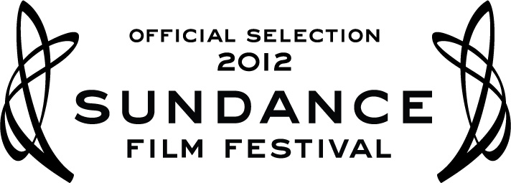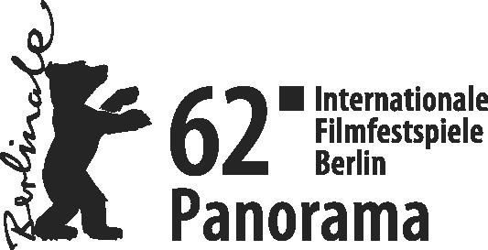

MY BROTHER
THE DEVIL
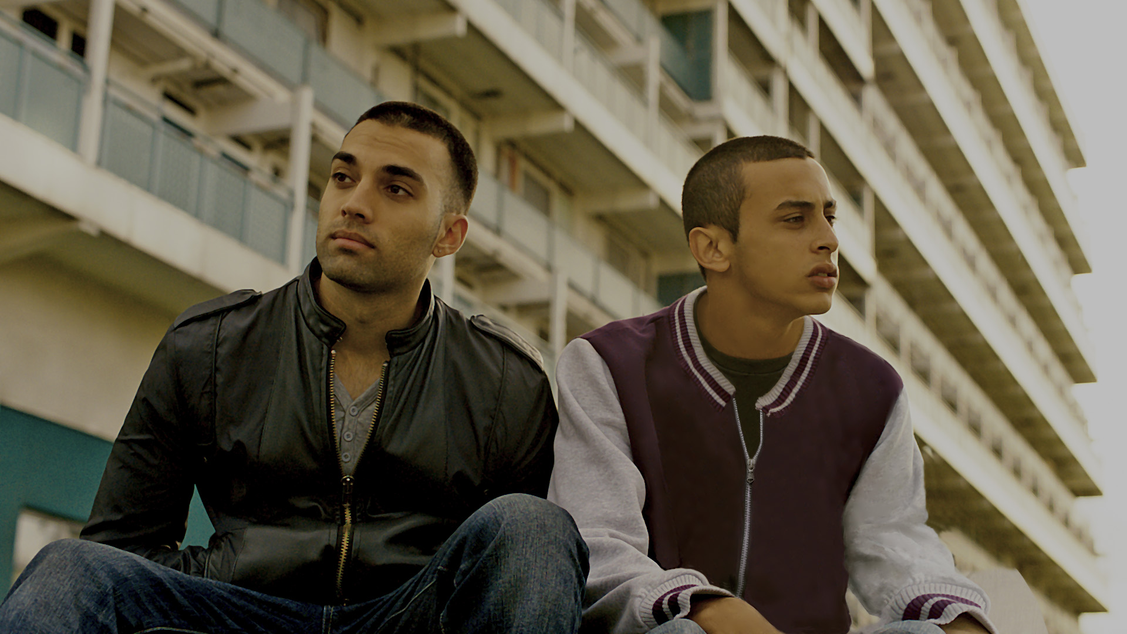
WRITTEN & DIRECTED BY SALLY EL HOSAINI
STARRING SAïD TAGHMAOUI, JAMES FLOYD, FADY ELSAYED

A WILD HORSES FILM COMPANY AND
ROOKS NEST ENTERTAINMENT PRODUCTION

TO OPEN IN CINEMAS IN NOVEMBER

Cert: tbc Running Time: 111 mins

For further information please contact:
Caroline Henshaw/ Sophie Roche at Rabbit Publicity
Tel: 020 7299 3685/ 3686
caroline@rabbitpublicity.com / sophie@rabbitpublicity.com

For photography please go to: http://www.vivaverve.com

CAST LIST

Saïd Taghmaoui as SAYYID
James Floyd as RASHID
Fady Elsayed as MO
Aymen Hamdouchi as REPO
Ashley Thomas as LENNY
Anthony Welsh as IZZI
Arnold Oceng as AJ
Letitia Wright as AISHA
Amira Ghazalla as HANAN
Elarica Gallacher as VANESSA
Nasser Memarzia as ABDUL-AZIZ

CREW LIST

Written & Directed by Sally El Hosaini
Producers Gayle Griffiths
Julia Godzinskaya
Michael Sackler
Executive Producers Sally El Hosaini
Mohamed Hefzy
Director of Photography David Raedeker
Production Designer Stéphane Collonge
Editor Iain Kitching
Casting Shaheen Baig and Aisha Walters
Costume Designer Rob Nicholls
Sound Designer Jovan Ajder
Music by Stuart Earl

SYNOPSIS

Mo is a young boy growing up in a traditional Egyptian household, but beyond the front door of the family's modest London flat is a completely different world – the streets of Hackney. The impressionable Mo idolizes his handsome and charismatic older brother Rashid and wants to follow in his footsteps. However, Rashid wants a different life for his little brother and will do what ever it takes to put him through college. Aching to be seen as a tough guy himself, Mo takes a job that unlocks a fateful turn of events and forces the brothers to confront their inner demons.

DIRECTOR’S STATEMENT

To me, MY BROTHER THE DEVIL is a film about the power of unconditional love. Although it touches on themes of prejudice and identity, at its heart it’s a love story between brothers. While writing the screenplay I had an image of a piece of DNA in my head. Each brother was a strand of the helix and their lives twisted and spiraled around each other; on separate paths, but forever connected. This was the genesis of Mo and Rashid's relationship, which is the spine and heart of this story. It's about a journey from a kid and idol relationship to true brotherhood. Both brothers must face up to who they really are if they are to be able to love each other. So, ultimately it’s also about the courage it takes to be different, to be yourself.
- Sally El Hosaini

Q&A with WRITER-DIRECTOR SALLY EL HOSAINI

Are there any experiences in your life that have helped to create the themes that are expressed in the film?
At sixteen my mother encouraged me to leave home and attend one of the United World Colleges. UWC’s are a unique organization – they are a global educational NGO that brings together students from all over the world to foster international and intercultural understanding. Being educated in this way has given me a strong sense of idealism, empathy and a love of celebrating the differences between people.
What motivated you to write and direct this story centered on two brothers?
I’m interested in people on the margins of society; outsiders and outcasts. I've lived in Hackney for ten years. I could see teenage boys hanging around my neighborhood and they fascinated me, especially the Arab boys who had a cultural upbringing to which I could relate. At first I was interested in the gang as a surrogate family. But the more I got to know the boys the less interesting or important the trappings of their world became. I was drawn to their personal struggles and stories, so I set out to make an honest film about them. Being the third of four children in my family, I wanted to explore a sibling relationship. As a middle child, my experiences of being both a little and big sister also informed the project.

How has being Welsh-Egyptian enhanced the story, your motivation for telling it, and the characters?
Being Welsh-Egyptian, I know how it feels to have opposed belongings and to live in two worlds that aren't always in harmony. MY BROTHER THE DEVIL is the story of what happens to brothers when these worlds collide, forcing them to make painful choices. Like the brothers in my film, I know what it’s like to have different, contradictory selves. In this way my own narrative has definitely influenced both my choice of story and characters. It continually forces me to accept contradiction. I always understand the other side of the argument so nothing is ever black or white for me. Being on the edge looking in, never fully belonging in either world, gives me a certain perspective that makes me passionate about telling stories that explore the contradictions of the world. I want to try to capture the complexity of people and the intricacies of life on film. With MY BROTHER THE DEVIL, I tried to address difficult questions about identity. I don’t have the answers and there are no easy answers, but by exploring the questions I hope that viewers will be provoked to look inwards and explore their own phobias and thought processes.
You expose us to a culture unknown by many, yet tell a story that feels inclusive and universal. How did you manage that?
I believe that to be universal is to be specific about certain truths, and authenticity was hugely important to me throughout the making of the film.
The focus of MY BROTHER THE DEVIL is the emotional and psychological story. Much of this is told through subtext. These interior dilemmas that the brothers face transcend language and culture. Also, choosing an experience-driven, subjective, shooting style allows us to enter the emotion of the characters. My ambition was always to tell this story from the inside looking out. The camera lingers with Mo or Rashid to allow us to delve beneath the surface, exposing the secrets each one carries. This builds an intimacy with the brothers.
I also didn’t want Mo and Rashid to be symbols for bigger concepts, as Arab characters often end up. They are just boys; London boys. They have an ambivalent relationship to Arab/Islamic culture that's both familiar and alien to them. Their concerns are the universal concerns of all teenagers. They want to look good, make some money to buy the latest gear, and have sex. Yes, they struggle to survive the gangs, drugs and violence, but they have other needs, desires, and dreams as well.

BEGINNINGS

London based writer-director Sally El Hosaini’s debut feature MY BROTHER THE DEVIL is the culmination of approximately five years work and development as well as the realization of a hard fought personal dream.

“When I first started working on the film it was immediately after the 7/7 bombings

occurred. The way Arabs - and Arab youths - were being portrayed in the media as some kind of terror threat bothered me. It didn’t represent the Arab boys I saw around me every day. I decided to make a film that treated their lives honestly, and conveyed their struggles. I knew from the very start that I wanted the film to be about brothers. That was the core relationship that I wanted to explore.”

El Hosaini soon realized that for her film to have the authenticity she desired, she would have to undertake some serious research. “My background is in documentary and that influenced my approach. I spent a few years getting to know boys in my neighborhood and spent a lot of time in their company and listening to how they spoke and the timbre of the language - I learned a new language in a way.”

For Welsh-Egyptian El Hosaini, building relationships with tough young men on the streets of her beloved Hackney was not the scary experience one might imagine and she quickly developed lasting relationships that went beyond those of writer and subject. “If I’d been a man, I don’t think I could have entered the world the way I did. I wasn’t a threat. Also being Arab and Muslim really helped.”

One lasting, and also formative, relationship El Hosaini developed was with Aymen Hamdouchi, who plays the pivotal role of gang member Repo in the film and was also script consultant from the very early stages. Hamdouchi adds authenticity and credibility to MY BROTHER THE DEVIL both on and off screen.

“I met Sally on [the Paul Greengrass film] GREEN ZONE in 2008, she was there helping with the production team. She was already hard at work on MY BROTHER THE DEVIL. She asked me if I’d like to read the script and consult. She really did her research. She went into the world of Hackney or ‘the streets’ and she brought me in to help her perfect it. I respected that.”

El Hosaini explains further, “We discovered that we both lived in Hackney. I realized that he was of that world I was writing about and our friendship grew from there.” Hamdouchi adds, “I helped with the small details. She knew all the basics; everything was there. I helped with the language and small things.”

Despite El Hosaini’s dedication to the project she was still, in those days, a long way from seeing her vision on the big screen so she continued her work as a script editor at BBC Drama. El Hosaini was accepted into the Sundance Middle East Screenwriters Lab, the Sundance Screenwriters Lab and the Directors Lab, and was then able to put her film together.

A film about Hackney life, with scenes populated by Hackney locals, could only really be filmed in one location: Hackney. The cast and crew of MY BROTHER THE DEVIL spent approximately five weeks on location in East London in August-September 2011, filming in and around the buildings of the New Gascoigne Estate. In addition to members of the cast already plucked from the streets, extras were recruited from the local community.

Just as the team was gearing up for production they encountered an unexpected and

unique problem – London was burning. Sally El Hosaini picks up the story, “Riots broke out in Hackney the day we did our camera tests. The riots meant that there was a ban on shooting any exterior scenes with fights with youths and guns or knives. In all of London throughout the shoot! That prompted some quick rewrites.”

The riots quickly subsided and the cast found that filming in Hackney was extremely beneficial and the locals welcomed the crew with open arms. Fady Elsayed spoke from the set about using his surroundings to get into character, “Shooting here in Hackney helps. While I’m filming I see people on their pedal bikes and kids hanging out and it just makes me feel like I’m involved.”

For James Floyd, who spent so much time in the area, the underbelly of Hackney was an inspiration, “You have new Hackney and old Hackney and most of this movie is set in old Hackney - the Hackney where the riots happened, where there’s different kinds of people and a lot of mischief.”

Saïd Taghmaoui enjoyed living and working in East London and learning about the people, “I really liked working with all the kids and learning about all their culture here in England because obviously things are different in France. I learned a lot about the differences between the French ghetto, where I am from, and the English ghetto. The only bad thing about this shoot was the English weather. Oh my god, that’s not a legend! It rains every bloody day in England and that’s a fact.”

GETTING INTO CHARACTER

With backers and producers in place El Hosaini got quickly to work assembling her cast, mindful that she wanted actors – or in some cases non-actors – and that certain elements of the film’s story would prove difficult to accept for some of the same boys with whom Sally had spent so much time on street corners.

JAMES FLOYD PLAYS RASHID

He may plot the lavish, materialistic lifestyle of a successful drug dealing gangster from his bunk bed, but Rashid (aka Rash, played by James Floyd) has contrasting ambitions for his little brother Mo, for whom he dreams of college and white collar safety.

Floyd was one of the first actors to sign and plays elder brother and charismatic gangster Rashid.

Says El Hosaini, “James was cast very early on in the process because I knew if I was going to have a professional actor play Rashid, I wanted to immerse them in the world. I had initially thought that I only wanted Rashid to be played by a non-actor but the subject matter of the film made that very difficult and most were too afraid.”

“Through Sally’s contacts and mainly through Aymen Hamdouchi, who plays Repo, I

spent time in that world. I said, ‘I’m an actor, I’m here to absorb your life and observe you’ and they were all cool with it. I spent as much time in that world as I could, a lot of time. Sometimes four or five nights in a row from 7pm to 7am – that’s their kind of hours, for five or six months.”

Aymen Hamdouchi quickly warmed to the young actor. “What I respected about James was that from the beginning he said, ‘I’m not from this world. I’m familiar with it, but it’s not me. I can’t tell you how to cut up coke or whatever but I’m dedicated’. I like that he pays attention to small details. He wants to know everything. We’ve gone out there and he met a lot of my friends who are in the streets still. I took him to some sticky places but it’s been fun and a good experience.”

FADY ELSAYED PLAYS MO

MY BROTHER THE DEVIL is told, for the most part, from the point of view of Mo. Mo is coming of age and, despite Rashid’s protests, clearly dreams about following in his big brother’s criminal footsteps. Finding a young actor who could portray this mixture of adolescent and adult, conscience and wayward impressionability, proved particularly challenging, but the answer was right at Sally El Hosaini’s doorstep all along. She says, “As we looked for a Mo, we held open casting calls and something like 600 kids turned up and we still couldn’t find the right person so we actually had casting scouts out on the streets bringing boys in.”

Says Sally, “I’d first met Fady at an anti-gun crime event at Arsenal stadium years ago when he was really tiny. At the time I thought he was way too young for the film and kind of forgot about him.”

However, as time went by Fady Elsayed literally grew into the part of Mo. “It eventually came down to two actors. Fady was in Egypt at the time, during the revolution, and he made huge efforts to get back. He came straight from the airport into the audition room because he was that dedicated,” says Sally.

SAïD TAGHMAOUI PLAYS SAYYID

Sally El Hosaini knew she needed a special actor for the key role of Sayyid. Originally from Paris, Sayyid is a photographer and acquaintance of Rashid’s best friend Izzi. Following Izzi’s violent death, Rashid and Sayyid forge their own relationship.

She explains, “I’d met Saïd when I first started working on the project and he was always a big supporter. He knew I was trying to do something real and urban with Arab boys and he was very encouraging. I realized that Saïd Taghmaoui brings a certain kind of masculine, alpha male energy and a realness, honesty and danger that goes against what is written in the script.”

Perhaps understandably, given the subject matter and the actor’s cultural background, there were a few bumps in the road to getting Taghmaoui into the part, “At first Saïd said no to playing the role. It took a while for him to come around. But from the beginning I pretty much wrote the role for him. In a way, his character from [Mathieu

Kassovitz’s] LA HAINE was an inspiration – what if that character moved to London X years later…’ she says. “This film is, on many levels, about what it means to be a man and I felt that, by casting someone as overtly masculine and alpha male as Saïd Taghmaoui, I would be able to explore that in quite an interesting way.”

AYMEN HAMDOUCHI PLAYS REPO

If there was one simple casting choice for MY BROTHER THE DEVIL, it has to be Aymen Hamdouchi, who plays Repo. In their gang DMG (Drugs, Money, Guns) Repo provides the muscle to complement Rashid’s brains. Hamdouchi plays Repo with a natural ease, but this was no surprise to him, “I always knew I was going to be Repo. I told Sally, that’s me. I can play Repo because I’m so familiar with these types of guys. As an actor it’s so simple. It’s like putting on your PJs!”

El Hosaini explains, “He auditioned like everybody else even though I secretly believed that he would be Repo - a lot of Repo’s lines were lifted directly from stuff I’d heard him say.”

The experienced Saïd Taghmaoui was impressed by the authenticity of Hamdouchi’s performance, “The guy needed a sense of realness that only a guy from the street, a real kid who lived it, can deliver to hit the right note. That was Aymen.”

ACTORS’ BIOS

James Floyd

James Floyd is an up-and-coming British actor. The Independent named him 'a star-in-the-making' and The Guardian profiled him in their prestigious 'First Sight' feature of April 2011.

He stars in MY BROTHER THE DEVIL (World Premiere here in Competition at Sundance) along side Saïd Taghmaoui (LA HAINE, GI JOE, THREE KINGS), directed by Sally El Hosaini. He also starred in EVERYWHERE & NOWHERE, directed by Menhaj Huda (KIDULTHOOD) which was released in UK and Europe and played at Mumbai and Dinard Film Festivals.

REARVIEW will be released 2012, along side Antonia Thomas (MISFITS) and directed by Avril E Russell. Other films include TORMENTED (Pathé/BBC Films/Forward Films), THE INFIDEL (Met Film) and ITV's huge ratings hit COMPULSION along side Ray Winstone and Parminder Nagra.

He is also an acclaimed theatre actor who has starred in Dov & Ali, The Glass Cage, amongst others.

Fady Elsayed

Fady Elsayed has been a member of the Young Actors Theatre for 3 years. Prior to his

role in MY BROTHER THE DEVIL, Fady filmed Brad Pitt’s feature film WORLD WAR Z and the feature films TWENTY8K, directed by David Kew, and ILL-MANORS, directed by Ben Drew. He has also had roles in the short films FREAKS (Daniel Jerome Gill) and ON YOUR WAY (Scott Watson). Fady has also worked on a BBC Language project and has corporate and modeling experience. He is an outstanding footballer and speaks fluent Arabic.

Saïd Taghmaoui

Saïd Taghmaoui is a Cesar-winning Moroccan-French actor. He’s best-known for his role as “Saïd” in the film LA HAINE directed by Mathieu Kassovitz, and as the U.S. trained philosophical Iraqi interrogator “Captain ‘My Main Man’ Saïd” in THREE KINGS. More recently, he appeared as “Omar,” the radical Islamic associate of Don Cheadle in the 2008 film TRAITOR. He also starred in VANTAGE POINT playing he leader of a terrorist group that plotted to kidnap the U.S. president. He also guest starred on the ABC TV show “Lost.”

His other credits include I ❤ HUCKABEES, THE GOOD THIEF, THE KITE RUNNER, HOUSE OF SADDAM, G.I. JOE: RISE OF COBRA and CONAN.

DIRECTOR’S BIO

Sally El Hosaini

Sally El Hosaini is a Welsh/Egyptian screenwriter and director. Her debut feature, MY BROTHER THE DEVIL (2012), stars James Floyd, Fady Elsayed and Saïd Taghmaoui. It’s produced by Gayle Griffiths of Wild Horses Film Company, and Julia Godzinskaya & Michael Sackler of Rooks Nest Entertainment. It was developed through the Sundance Directors and Screenwriters Labs, RAWI Screenwriters Lab, and Babylon Development Initiative. Sally was one of Screen International’s UK Stars of Tomorrow 2009. Her short film, THE FIFTH BOWL, won a regional BAFTA. Another short, HENNA NIGHT was officially selected for London Lesbian & Gay Film Festival, in competition at Rotterdam and Raindance, and screened at the ICA and BAFTA. It’s distributed internationally by Peccadillo Pictures. She has also co-written the Iranian/American feature film CAMELIA. Prior to writing and directing Sally script edited and was the specialist researcher on BAFTA & EMMY winning, HBO Films/BBC Drama mini-series HOUSE OF SADDAM. Before that she was a production coordinator in features and worked on several Middle East documentaries.

