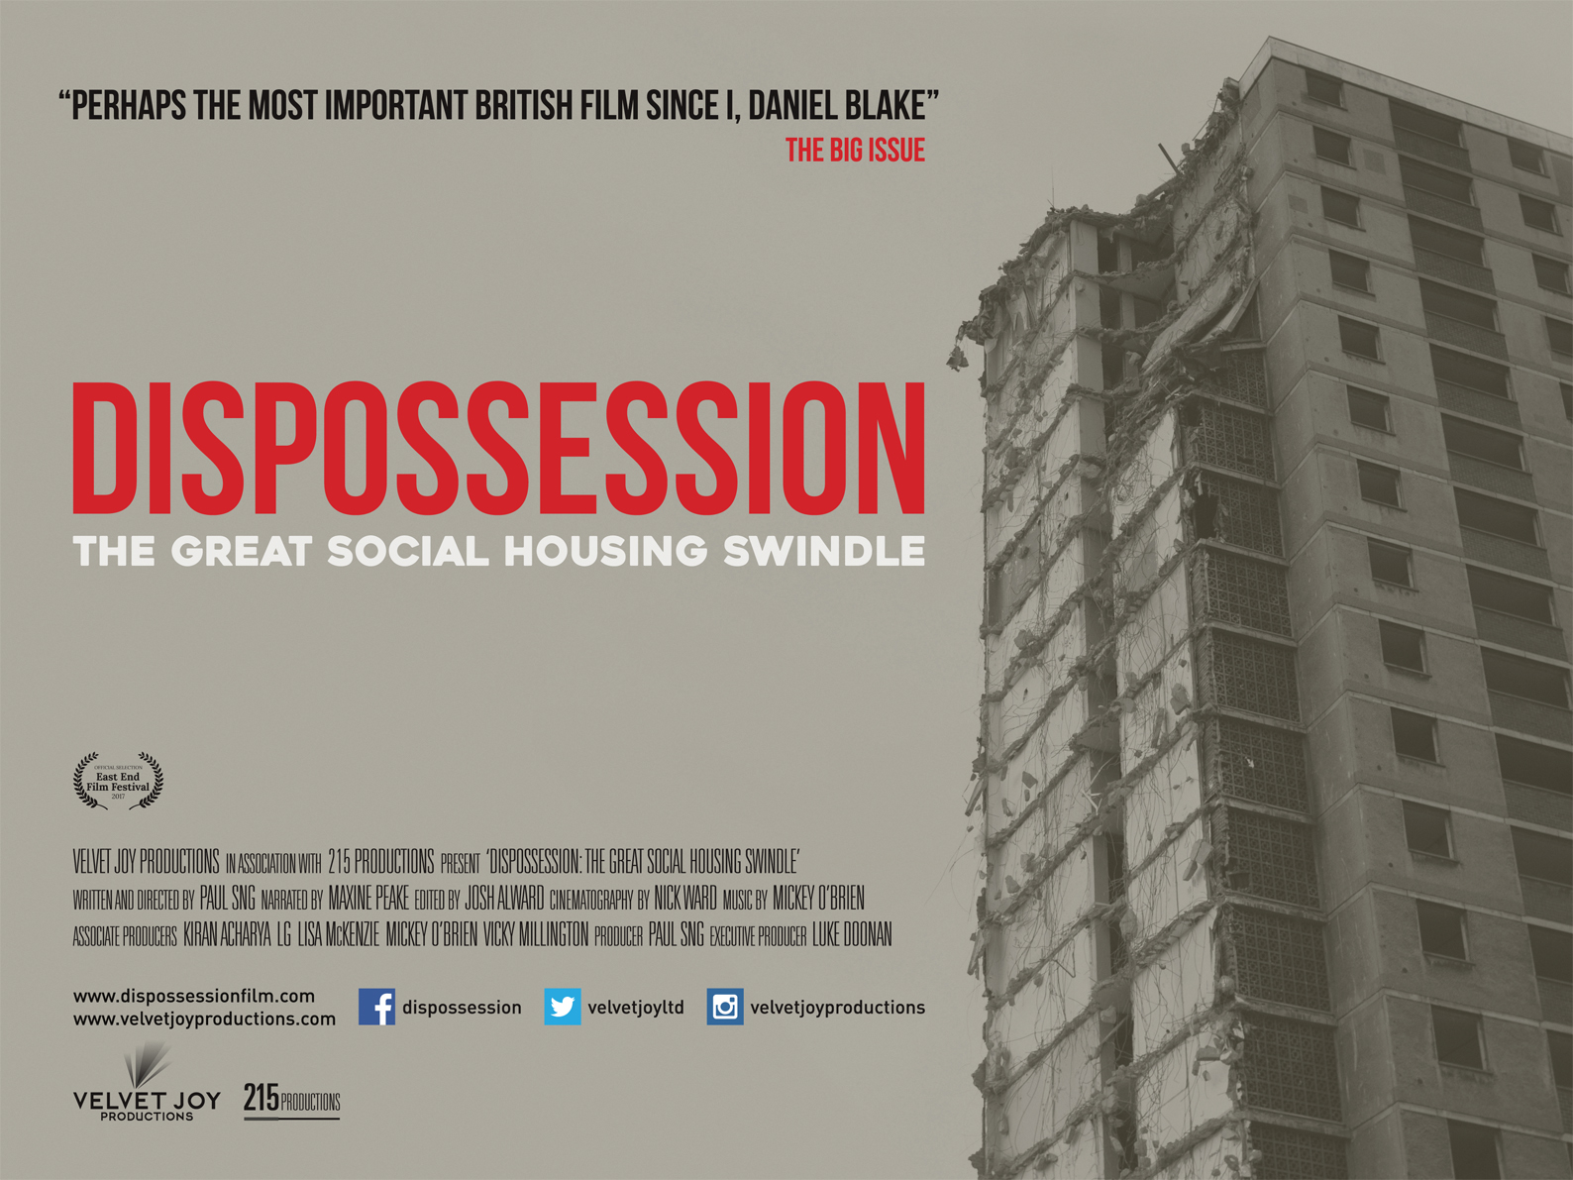

DISPOSSESSION: THE GREAT SOCIAL HOUSING SWINDLE

DIRECTED BY PAUL SNG

NARRATED BY MAXINE PEAKE

Certificate: PG Running time: 82 mins

A VELVET JOY PRODUCTION

"The housing crisis is one of our nation’s biggest scandals and this film shows us it’s deliberate. A must see independent film." – Michael Sheen, actor

“A disturbingly timely film that delves into the murky world of public housing, political manoeuvring and deceit. See it and be troubled…” – Rebecca O’Brien, producer I, Daniel Blake, Raining Stones, My Name Is Joe

www.dispossessionfilm.com

Facebook: Dispossession Twitter: @velvetjoyltd #dispossessionfilm

For press enquiries, contact:
Paul Smith - paulwsmithpr@gmail.com

DISPOSSESSION: THE GREAT SOCIAL HOUSING SWINDLE

SYNOPSIS

For some people, a housing crisis means not getting planning permission for a loft conversion. For others it means, quite simply, losing their home. Dispossession: The Great Social Housing Swindle is a feature documentary directed by Paul Sng (Sleaford Mods – Invisible Britain) and narrated by Maxine Peake, exploring the catastrophic failures that have led to a chronic shortage of social housing in Britain.

The film focuses on the neglect, demolition and regeneration of council estates across the UK and investigates how the state works with the private sector to demolish council estates to build on the land they stand on, making properties that are unaffordable to the majority of people. Dispossession is the story of people fighting for their communities, of people who know the difference between a house and a home, and who believe that housing is a human right, not an expensive luxury.

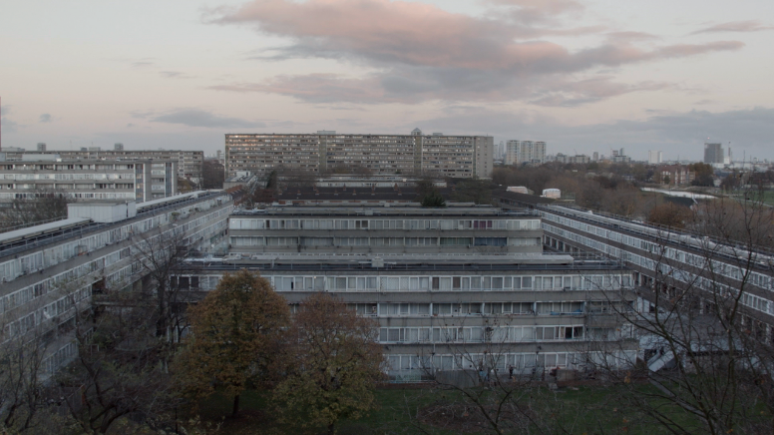

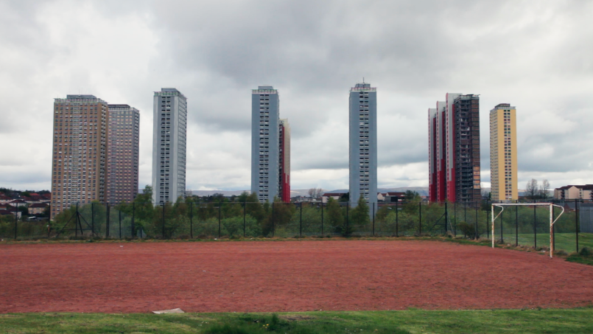

DIRECTOR’S STATEMENT
I decided to make Dispossession when I became aware of the Housing & Planning Bill in late 2015 (which became the Housing & Planning Act in May 2016). At the time, the government claimed the legislation was designed to address the housing crisis, yet its key purpose is to promote home ownership, something far beyond the means of most people under the age of 30 in the UK. But the most damaging aspect of the Act is the threat it poses to council housing, something that successive governments have neglected for decades.
At the end of the 1970s, 42% of the population lived in council housing. Today, that figure has fallen to less than eight per cent. As a society, we seem to have forgotten what the purpose of social housing is: to provide families and individuals with affordable and stable accommodation. Yet the portrayal of council estates in the arts and media is nearly always negative, which helps to encourage the idea that the people who live there have somehow failed in life. This demonisation has helped create a false narrative for the state to justify the demolition of inner city estates, where property and land value is at a premium.
With Dispossession we wanted to show the reality of living on an estate and explore how the social cleansing of inner city areas with covetable postcodes is breaking up working class communities. I hope the film will help raise awareness about what’s happening to council estates across the UK and encourage people to defend their homes and communities from demolition.
Paul Sng, May 2017.

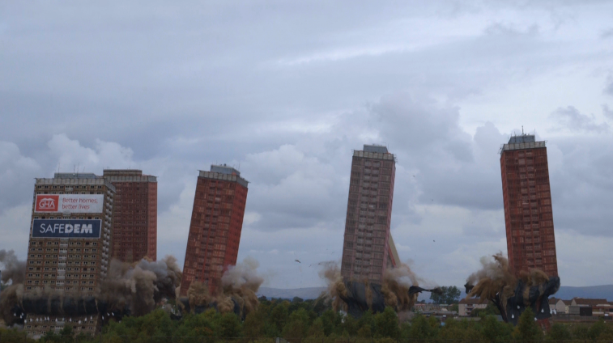

CREDITS

Director/writer: Paul Sng
Narrator: Maxine Peake
Producer: Paul Sng
Associate Producers: Kiran Acharya, Lisa McKenzie, Mickey O’Brien, Vicky Millington
Executive Producer: Luke Doonan
Editor: Josh Alward
Cinematography: Nick Ward
Camera: Kiran Acharya, Nick Ward
Additional Camera: Lee Skelly
Photography: Robert Clayton
Additional Photography: Alessia Gammarota, Lisa Wormsley, Mark Chester, Rab Harling, Ravi McArthur, Vicky Millington
Sound Editor: Alex Gregson
Music: Mickey O’Brien
Music Mixed And Mastered: Tom Gillieron At Artspace Studios, London (Except ‘St Ann’s’, Mixed And Mastered By Stuart Bevan)
Graphics: Jack Brown, Tony Shephard
Transcriptions: Dan Butler, James Morgan, Rob Conlon, Vicky Millington
Research: Alastair Ball
Interviewees:
Alisdair Doherty Alison Thewliss, MP Andrew Smith Andy Plant Angela Keating Beverley Robinson Caroline Lucas, MP Catherine Ryder Chantal Lee Chris Leslie Christopher Monckton Daniela Scotece Danny Dorling Dawn Foster Deborah Orr Eileen & Michael O'Keeffe Florence Eshalomi Frances Stojilkovic Gary Barton Gavin Werry Gisella Sobarasua Glenn McMahon Helen Foster Jade Murphy James Cook , MBE Jamie Burton Jamielee McCaughey Jason Browning Jim Fitzpatrick, MP Jim Monaghan Joe Beaver Karen Buck, MP Lisa McKenzie Liz Crosbie Nicola Sturgeon, First Minister of Scotland Paddy McManus Pam Douglas Peter Hitchens Rab Harling Ronda Daniel Rushanara Ali, MP Ruth Carson Sian Berry Siân Steans Simon Elmer Soryia Siddique Stephen Pritchard Steve Turner Tim Morton Toby Lloyd Tom Keene Tom Murtha Valerie Wright

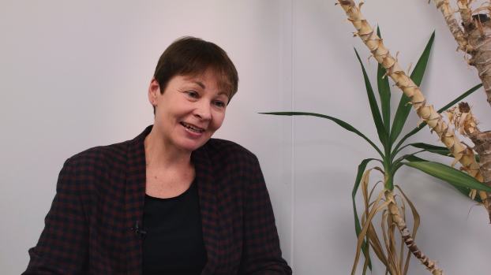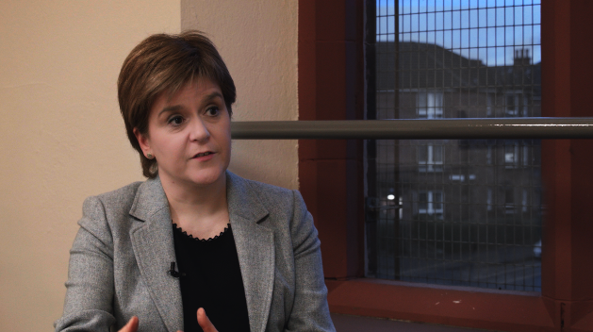

BACKGROUND TO THE FILM

Dispossession: The Great Social Housing Swindle is a feature documentary narrated by Maxine Peake, exploring the failures and deception that have caused a chronic shortage of social housing in Britain.

The documentary focuses on the neglect, demolition and regeneration of council estates in London, Glasgow and Nottingham, and examines the human cost of the housing crisis via interviews with residents, politicians and housing experts in the building industry and media.

Between 1946 and 1981, five million council homes were built in Britain. At the end of the 1970s, 42% of the population lived in council housing. Today, that figure has fallen to less than eight per cent. When the Right to Buy scheme was introduced in 1980, it granted council tenants the legal right to purchase their home at a 33% to 50% discount of the market value. By 1996, 30% of tenants had exercised this right and 2.2 million homes had been transferred into private ownership.

Two decades later, 40% of ex-council homes sold via Right to Buy are now rented out more expensively by private landlords. And successive governments have prevented councils from spending the money accrued from Right to Buy on replacing the housing stock that was sold off. This is the main reason we have a social housing crisis in Britain.

Housing associations are also culpable: between 2000-2014 they received in excess of £62 billion in funding, yet built only 26,000 homes per year on average, just half the number required to meet demand. In 2015, England's largest housing associations recorded a £3 billion surplus. The same year, the estimated number of people on the social housing waiting register in England reached 1.7 million.

The production team was granted unprecedented access to residents in London’s Cressingham Gardens, where the community is currently fighting a demolition order from Lambeth council. On the edge of Brockwell Park in leafy Cressingham Gardens we meet elderly couple Eileen and Michael O’Keefe, who face losing the home they have lived in for 35 years, as their neighbours rally around to prevent demolition of the estate.

On the Aylesbury Estate Beverley Robinson along with other residents are challenging Southwark council’s plans to demolish the estate. Beverley is faced with the prospect of selling her two bedroom flat for what the council deem the market value, which is considerably less than the cost of a like-for-like replacement in the area. In March 2015, the council spent a reported 140,000 pounds erecting a high fence, topped with razor wire, around the estate. As well as being isolated in her home, Beverley has to be let in and out from the building by a security guard at the entrance gate.

We also meet Gavin Werry, a former resident of the architect Ernő Goldfinger’s Balfron Tower, who wants nothing more than to return to the home that was taken from him when the iconic building was transferred from local authority ownership to housing association Poplar HARCA. Despite promising to keep all social rent tenants, the company would later ‘decant’ all of them in order to redevelop the property for the sale of luxury apartments.

The documentary also examines the repercussions of Glasgow City Council’s decision to transfer all council housing stock to the Glasgow Housing Association (thus removing all council housing from the city) and visits the Gorbals and Govanhill, two areas with contrasting fortunes in the wake of this decision.

Paddy McManus is our guide to the Gorbals, a once a no-go area for non-residents, notorious for gang violence and drugs. Paddy lived through the tidal wave of heroin that hit Glasgow in the 1970s, and was forced to become homeless in order to qualify for a place in one of the remaining social houses. Although the regeneration of the Gorbals means it been transformed to an area with a booming property market, only a quarter of properties are now available for social rent. On the newly-created private market, one-bedroom flats rent for £500 or £600 a month – a sum that puts Gorbals housing well beyond the reach of the original residents.

In Govanhill we meet t Liz Crosbie and Francis Stojilkovic from the Govanhill Community Campaign, who are campaigning for an end to Victorian-era slum conditions in First Minister of Scotland Nicola Sturgeon’s own constituency. Many homes are infested with cockroaches and bedbugs, and outside there are rats – on most streets rubbish is piled high with mattresses and furniture dumped on the pavements. Sturgeon is charged with failing to address the problem of rogue landlords and the social issues created by a lack of social housing, while campaigners Liz and Francis reveal a divided community where growing resentment of the migrant population suggests that the SNP’s desire for Scottish independence in order to remain part of the EU is by no means universally popular. They ask who should be held accountable for the degeneration of Govanhill, as they escalate their headline-grabbing campaign.

In Nottingham on the St Ann's estate we follow Dr Lisa McKenzie, a working class academic who grew up here, an area stigmatised as a place where gangs, guns, drugs, single mothers and those unwilling or unable to make something of their lives reside. Lisa introduces us to a community where we find strong, resourceful and ambitious people who challenge the simplistic notion of the ‘sink’ estate.

The legislation introduced in the Housing and Planning Act means that council housing as we know it is being abolished. Dispossession tells the stories of people who are fighting to save their homes and preserve their communities from the effects of social cleansing and gentrification – people like Ronda Daniel, a 20-year-old student from the Becontree Estate in Dagenham, who is struggling to balance studying for a Sociology degree and helping to care for her disabled brother. We explore alternatives to demolition with Simon Elmer from Architects for Social Housing (ASH), a collective of building design professionals who provide alternatives by producing plans for adding new homes to existing structures.

Dispossession investigates how the state is working with the private sector to demolish estates to build on the land they stand on, making properties that are unaffordable to the majority of people in the UK. It’s the story of people fighting for their communities, of people who know the difference between a house and a home and who believe that housing is a human right, not an expensive luxury.

BIOGRAPHY
DIRECTOR – PAUL SNG
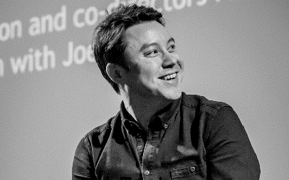
As a director and producer, Paul’s work focuses on telling the stories of people who challenge the status quo.
His first feature documentary, Sleaford Mods – Invisible Britain, is a part band doc, part state of the nation film that follows the band Sleaford Mods on a tour of the UK in the run up to the 2015 General Election. In each location the filmmakers interviewed members of the local community in neglected towns and cities to examine how austerity, de-industrialisation and unemployment had impacted on the area and what, if anything, they were doing to campaign against unpopular government policies. The film was conceived in December 2014 and crowdfunded successfully in February 2015; eight months later it premiered at Picturehouse Central in London and has been shown on more than 80 screens in the UK and Ireland.
Following the success of Invisible Britain, Paul formed Velvet Joy Productions, an independent studio based in Brighton that explores the lives and works of individuals who have been neglected, marginalised or misrepresented in mainstream media. His next film is a documentary about the failures and deception behind the social housing crisis, Dispossession: The Great Social Housing Swindle, which will be released in 2017. Upcoming projects include Poly Styrene: I Am A Cliché, a documentary celebrating the life and work of the X-Ray Spex front woman and punk icon, and Getting By, a film about the true reality of being working class in post-Brexit Britain, based on sociologist Dr Lisa McKenzie’s acclaimed book.

ABOUT VELVET JOY PRODUCTIONS
Velvet Joy Productions is an independent studio based in Brighton that focuses on telling the stories of people who challenge the status quo. Set up by director/producer Paul Sng in 2015 to explore the lives and works of individuals who have been neglected, marginalised or misrepresented in mainstream media, to date the studio has released two feature documentaries, Sleaford Mods –Invisible Britain (2015) and Dispossession: The Great Social Housing Swindle (2017). BACKGROUND TO THE FILM

