OLD BOYS

A film by Toby MacDonald
Written by Luke Ponte and Freddy Syborn

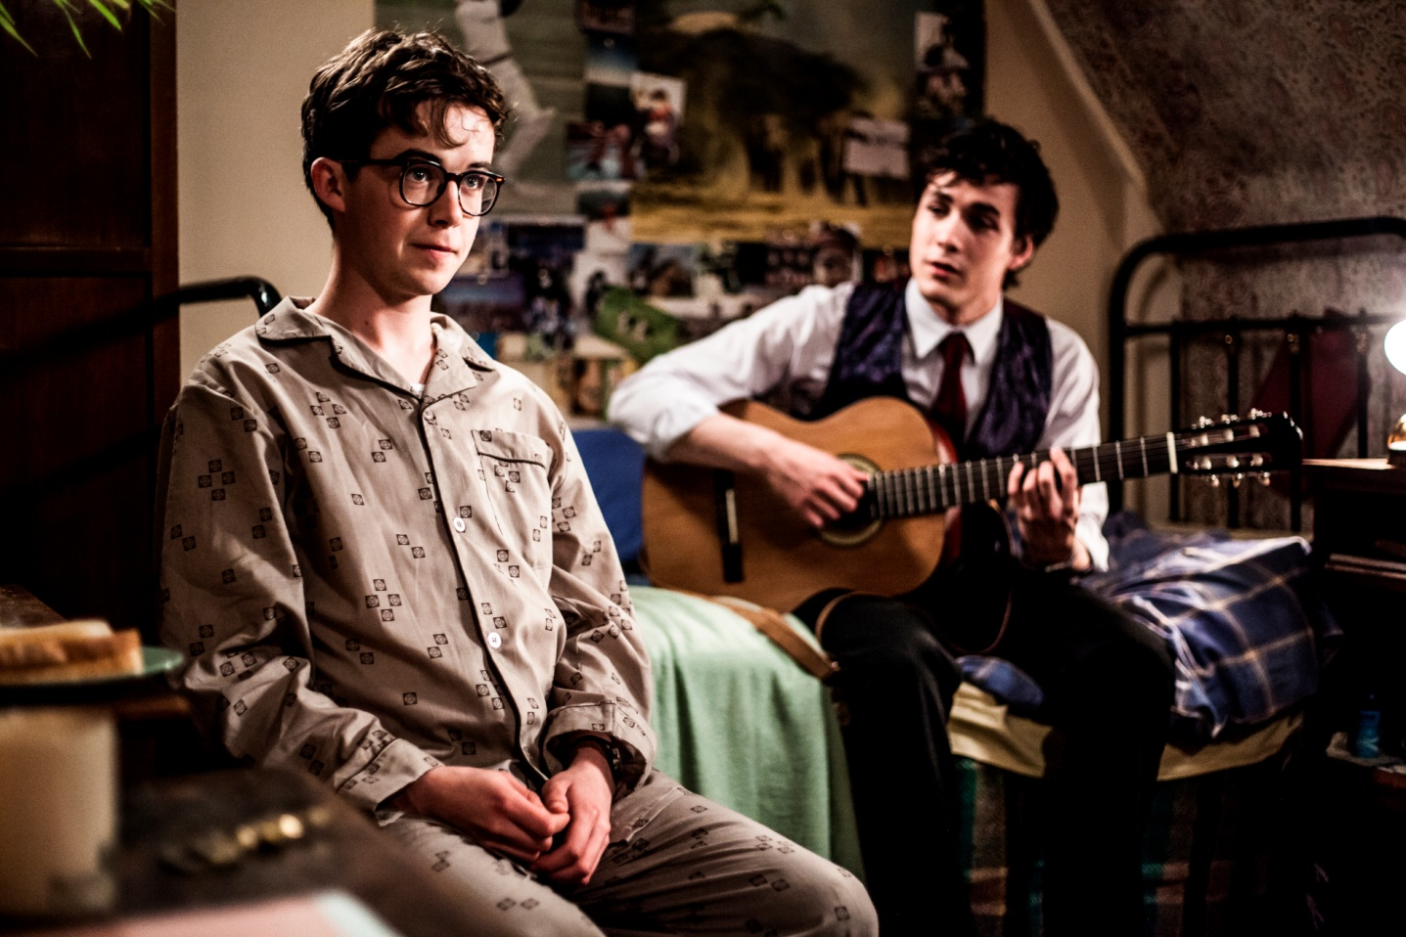

For all publicity enquiries please contact:
keeley@emfoundation.com
Certificate: 12A /Running time: 95 minutes
SHORT SYNOPSIS
In this school-set re-working of Cyrano de Bergerac, an awkward but imaginative pupil helps the handsome but spectacularly dim school-hero pursue the fiery daughter of a visiting French teacher.

SYNOPSIS
‘Survival of the fittest’ is the philosophy at all boys’ boarding school Caldermount. If you’re not a champion on the sports field, you’re a nobody. No one knows this better than bookworm Amberson, who’s been at the bottom of the school’s social ladder since he can remember.

When the French teacher’s fiery daughter Agnes arrives, Amberson’s life is turned upside down. He suddenly finds himself playing matchmaker for Winchester, the school’s handsome but spectacularly dim school-hero. Winchester definitely has the looks to win over Agnes but it’s Amberson who has the wits.

Will Amberson have the courage to reveal himself to her and stand up for who he really is?

A fresh and vibrant comedy, Old Boys is a modern twist on the timeless story of Cyrano de Bergerac.

DIRECTORS STATEMENT

To a romantically hopeless, day dreaming adolescent, the Cyrano story felt like it spoke right to every excruciating part of being a teenager. That distinctive Cyrano feeling - failed but heroic romanticism combined with unrequited love - captured the utter uselessness of me and most of my teen friends. The big nose is awkward, painful adolescence - always there, inescapable, debilitating, the first thing anyone notices.

For me, it was the stunning movement and sweep of the Rappeneau/Depardieu version that brought that Cyrano feeling to life. For lots of collaborators on the film it was ‘Roxanne’ with Steve Martin. We wondered what would have happened if Cyrano had the courage to tell Roxanne the truth - how would he have summoned up the courage? What would have been the worst thing that could have happened? It seemed like a wonderful moment in a coming of age story - with the help of a friend, a teenage liar comes clean and his life story really begins.

The other element to the Cyrano story that struck a chord was emotional repression, the idea of burying your true self, hiding it away - a particularly English trait that everybody can identify with. Where would an imaginative boy, different, a real outsider, need to bury himself?

The single sex boarding school is a quintessentially English institution. Arcane places where boys are handed over by their parents to learn how to be men, to conform, a chap factory that turns out the right kind of fellow. These are the boys who run the country. They are told they are great, that they are going to be great and they believe it. Strictly hierarchical, deeply unimaginative, brimming with unfounded over confidence, feelings buried and, crucially, absolutely no women.

The absence of girls is a disaster for these boys. Sports become everything. The school is their family. They are clueless and yet they think they know it all. How do they react when a real girl arrives? What happens when their bravado runs out? Who would they turn to for help? Not only are these teenage boys useless, they barely see any girls ever.

It’s not really a good time to be telling a story with only one girl in it set at a ‘posh’ boarding school - but as the establishment seems to have lifted back its own veil, it feels relevant to be looking at the places that made these boys into our rulers, into what happens at these girl-less places where boys are told to act manfully. Oddly popular again post Potter, they have been given a lick of paint, some soft furnishings and continue to be a source of fascination.

The boarding school genre has been an intermittent staple of British cinema, with Lindsay Anderson (via Jean Vigo) towering over it. We wanted to add something fresh - to look at the inner life of one of these boys, an underdog, colliding John Hughes with Edmond Rostand at a strange, isolated, prison like all boys boarding school.

Amberson is desperately trying to invent himself the way the school wants him to be, to fit in - he optimistically tries to overcome his class but they will never let him. He’s never been skiing. Agnes is tough, vulnerable, funny. She has a depth and maturity that is way beyond these boys. And yet she is a teenager too, when she lets herself be. Together, Agnes and Amberson are the heart of the film. A teenage boy and girl trying to work out who they are and where they are going.

“Your life begins when you are born, but your life story begins at that moment when you discover that you are in the wrong family” - Phillip Pullman.

Toby Macdonald

CAST

ALEX LAWTHER – AMBERSON
Screen International ‘Star of Tomorrow’ and BAFTA Breakthrough Brit, Alex Lawther is well known for his role as the young Alan Turing in the Oscar-winning film The Imitation Game, for which he was nominated for the ‘Best British Newcomer’ Award at The 58th BFI London Film Festival, and won the London Critics’ Circle Award for ‘Young British Performer of the Year’.

He followed this with roles in films including James Graham’s X+Y, Andrew Steggall’s Departure, which won him the Best Actor Award at the 2016 Dublin International Film Festival; Trudie Styler’s Freak Show, Simon Amstell’s Carnage, Jeremy Dyson and Andy Nyman’s Ghost Stories and Simon Curtis’ Goodbye Christopher Robin. His TV work includes the Emmy Award-winning series Black Mirror, in which he starred in the episode ‘Shut Up and Dance’, the BBC’s miniseries Howards End and the BAFTA and Emmy Award nominated Channel4/Netflix comedy teen drama The End of the F***ing World.

An accomplished stage performer, Alex made his professional debut aged 16 in David Hare’s South Downs. He was most recently been seen in acclaimed play The Jungle, a semi-verbatim production about the eponymous refugee camp in Calais, which debuted at the Young Vic in December 2017. The production recently transferred to Broadway and will complete run at St. Ann’s Warehouse in New York at the end of January.

JONAH HAUER-KING – WINCHESTER
Jonah Hauer-King’s first feature was a lead role in Danny Huston's The Last Photograph, followed by Ashes in the Snow alongside Bel Powley. He acted in and wrote for the soundtrack for Postcards From London, and made his West End debut playing Kenneth Branagh’s son in The Entertainer. He starred in the BBC miniseries Howards End with Hayley Atwell and Matthew Macfadyen and Little Women with Emily Watson, Angela Lansbury and Michael Gambon.

His upcoming films include A Dog’s Way Home and Once Upon a Time in Staten Island alongside Naomi Watts.

PAULINE ETIENNE – AGNES
Beginning her career at 18, Pauline Étienne quickly caught critic and audience’s attention with an award-winning performance in Guillaume Nicloux’s adaptation of Denis Diderot’s La Religieuse.

Born in Ixelles, Belgium, Pauline works in both French and English-speaking productions. Early on she was awarded with the Lumières Award for Most Promising Actress (2010), for Qu'un seul tienne et les autres suivront, and quickly followed through with that title with work in L’autre monde, La Religieuse, and Eden.

Since then, she has worked on more features, shorts, and television, including Sage femme, Sur quel pied danser and TV show, Le Bureau des Légendes. Acting in mostly France and Belgium-based films, Pauline moved over to a English boys boarding school for Toby MacDonald’s Old Boys, where she plays the love interest.

JOSHUA MCGUIRE – HUGGINS
A stage, radio, television and film actor, with a broad and diverse audience to his varied work, Joshua has worked with esteemed companies such as the National Theatre, Old Vic Theatre, Netflix, Channel 4, Walt Disney Pictures, and the BBC.

Recently on stage at the Old Vic with Daniel Radcliffe for Rosencrantz & Guildenstern Are Dead, Joshua divides his time between extended productions in the West End, to roles in television and film. In 2016, before starting work at the Old Vic, Joshua finished on Old Boys, playing Deputy Headmaster Huggins, acting in The Happy Prince, with Rupert Everett and Colin Firth, along with his regular role as Angus in Netflix’s Lovesick.

Joshua is also recognized by a large audience through parts in Kenneth Brannagh’s Cinderella, Richard Curtis’s About Time and Mike Leigh’s Oscar-nominated Mr. Turner. He shares the silver-screen spotlight with that of the stage, playing the title roles in Amadeus and Hamlet, as well playing opposite John Lithgow The Magistrate at the National Theatre.

Joshua also has a passion for writing and has recently penned the short, The Dying Hours, with Ruth Wilson, Luke Treadaway and Lindsay Duncan starring in the 8-minute film.

DENIS MÉNOCHET – BABINOT
Denis Ménochet is a French actor, who began his career in his twenties, starting in TV before expanding into shorts and feature films. He became an international star after appearing in Quentin Tarantino’s Inglorious Basterds, going on to work with Ridley Scott, Stephen Frears, and François Ozon. He continues to work in both French and English-speaking productions, as well as switching between features, shorts and television.

Recently he was seen in Assassin’s Creed alongside Michael Fassbender, and shared the lead in Netflix series, Spotless. His work is showcased all over the globe, along with entering dozens of festivals, such as Festival de Cannes, Chicago International Film Festival, San Sebastián International Film Festival, and Edinburgh International Film Festival.

FILMMAKERS

TOBY MACDONALD – DIRECTOR
Toby Macdonald started working on film sets as a runner at the age of 16. His short film Je T’aime John Wayne, about a young Englishman obsessed with the French New Wave, was nominated for a BAFTA, selected for Directors Fortnight in Cannes, won the TCM Prize for Best Short at the London Film Festival and won the European Film Academy Award for Best Short.

His follow up, the critically acclaimed short Heavy Metal Drummer, was also nominated for a BAFTA and was selected for film festivals all over the world. Shot in Morocco in Arabic, it told the story of a teenage drummer and his unrequited passion for metal. Toby has directed award-winning commercials working with Partizan London and the series ‘My Life In Film’ for BBC2.

LUKE MORRIS – PRODUCER
Luke is a twice BAFTA-nominated independent producer with a focus on new and next generation forms of production, distribution and exhibition.

He began his career as a Producers Assistant before working as a Production and Acquisition Executive with the UK Film Council (now BFI). He is the founder, producer and distributor of acclaimed short film label Cinema16, which released shorts from directors including Chris Nolan, Mike Leigh and George Lucas.

He’s a producer of films including music documentary All Tomorrow’s Parties and classic short Je t’aime John Wayne and has worked as a distributor or consultant on numerous projects including films by Lynne Ramsay and Harmony Korine.

He is a regular collaborator with Warp Films where he worked for seven years on production and distribution projects.

From 2011 to 2013 he collaborated with live cinema pioneers Secret Cinema, producing or executive producing their innovative immersive film events at a time when over 200,000 attended and its audience network grew to over half a million people.

Old Boys is his first narrative feature film.

FREDDY SYBORN – SCREENWRITER
Freddy has co-written Bounty Hunters (Sky One, airing this October) and three series of Bad Education (BBC3). He has written another sitcom, Cockroaches (ITV2), the Sky Arts Urban Myths episode about the young David Bowie, and several sketches for Psychobitches (Sky Arts).

Freddy has co-written two feature films: The Bad Education Movie (2015) and Old Boys.

Freddy's first short film as writer-director, Isla Traena, was shown at the London Short Film Festival, as well as Palm Springs, Mill Valley, New Orleans and San Jose film festivals.

Damascene, Freddy's first feature as writer-director, was shot for £3000 and selected for the New Orleans Film Festival. It was produced by Hayley Williams, whom he met on the set of Old Boys.

NANU SEGAL – CINEMATOGRAPHER
Nanu Segal is an award-winning cinematographer based in the UK.
Following a master's degree in chemistry at Oxford University, Nanu worked as a camera assistant, before training as a cinematographer at the National Film and Television School in Beaconsfield, England. Since graduation, Nanu has shot a wide range of feature films, from art house (Old Boys, An Evening With Beverley Luff Linn, The Levelling, All Good Children), to genre (Donkey Punch, The Children), as well as numerous short films which have collected many awards from film festivals across the globe (Cannes Cinefondation Award / BAFTA / Rhode Island).

Alongside her narrative work, Nanu regularly shoots commercials for companies such as Blink, Somesuch, Rattling Stick, Smuggler and MJZ, to name a few.
Nanu’s work has taken her all over the world, from her home turf of London, to the US, South America, Africa and all through Europe.

SAM SNEADE – EDITOR
Sam Sneade has made his name primarily by cutting TV commercials for the likes of Tony Kaye and Jonathan Glazer. This lead him to cut his first feature film Sexy Beast (Jonathan Glazer) in 1999, going on to work on his second film Birth in 2003. Sam has continued to combine commercials and film ever since; notably Stoned (2005, Stephen Woolley), Wight Lightning (2003, Dominic Murphy), more recently completing work on The Favourite (2017, Yorgos Lanthimos) and of course Old Boys with Toby McDonald (2017).

MARK TREND - EDITOR
Mark started his editing career with music videos and short films. Early shorts included Bale (dir. Al Mackay), which played at several international film festivals after premiering at Edinburgh. Music promos included work for UNKLE, Kate Nash, and Damien Rice. Mark still occasionally cuts short films, including most recently Three Women Wait For Death (Dir. Isabelle Sieb - Winner: Encounters, Best Live Action Short; BAFTA longlisted), and Yes, God, Yes (Dir: Karen Maine - Vimeo Staff Pick 2017).

Mark's first feature film as editor was the BFI and Creative England-supported, low-budget experimental film Norfolk (dir. Martin Radich), which premiered at Rotterdam, and went on to play at many other festivals, including Edinburgh and Dinard. Since then, he has also edited the British road-trip comedy Burn Burn Burn (dir. Chanya Button - Winner: LOCO Discovery award; Odessa Film Festival audience award), and the WW2 occupation drama Another Mother's Son (dir. Christopher Menaul), making Old Boys Mark's fourth feature film credit as Editor.

Recent forays into Television have included BBC3's critically praised Five By Five (dir. Kate Herron) starring Idris Elba, and Liam Williams' Valentine (dir. Jonathan Schey) for SKY Comedy. Mark has also cut several commercials for clients such as Samsung, Alfa Romeo, Help Refugees, and Oxfam.

Mark’s next feature as editor is Chanya Button's Vita & Virginia, starring Gemma Arterton and Elizabeth Debicki.

WRITTEN by
Luke Ponte and Freddy Syborn

DIRECTED by
Toby MacDonald

CAST
Alex Lawther as AMBERSON
Pauline Etienne as AGNES
Jonah Hauer-King as WINCHESTER
Joshua McGuire as HUGGINS
Denis Ménochet as BABINOT
Nicholas Rowe as HEADMAN
Eros Vlahos as JOHNSON
Robbie Fraser as VICKERS
Giles Malcolm as AUDLEY
Jack Stimpson as NELSON 1
David Gordon-Dixon as NELSON 2
Archie Merry as HOOD
Earl Cave as BETTING BOY 1
Joshua Knight as BETTING BOY 2
Nicholas Agnew as JONTY
Kate Bone as BABINOT’S DATE
Martin Savage as AMBERSON’S DAD

PRODUCER
Luke Morris

EXECUTIVE PRODUCER
Sam Lavender
Natasha Wharton
David Kosse
Paul Ashton
Robin Fox

CO-PRODUCER
Kasia Malipan
Erik Hemmendorf

DIRECTOR OF PHOTOGRAPHY
Nanu Segal
EDITOR
Sam Sneade
Mark Trend

PRODUCTION DESIGNER
Max Bellhouse

MUSIC
Andrew Hewitt

COSTUME DESIGNER
Bex Crofton-Atkins

MAKE-UP AND HAIR DESIGNER
Konnie Daniel

CASTING DIRECTOR
Shaheen Baig
Aisha Walters

