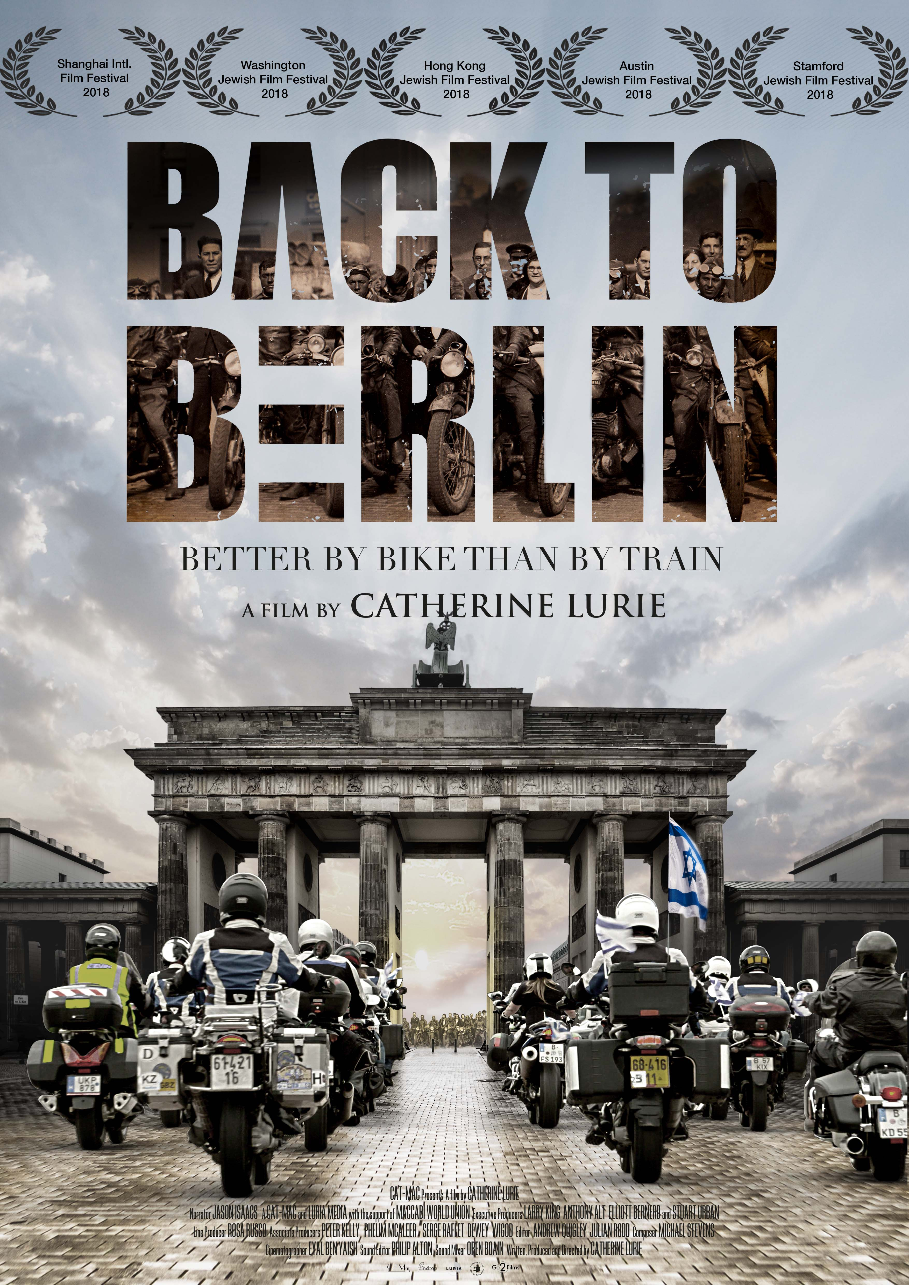
FILM INFO
Original Title Back to Berlin
Genre Documentary
Nationality British
Year May 2018
Format HD, 16:9, Colour and Black and White
Duration 59 + 76 minutes approx.
Locations Israel, Greece, Bulgaria, Romania, Hungary, Slovakia, Poland,
Czech Republic, Germany
Languages English, Hebrew, German
Website www.backtoberlin.co.uk
Contact Cat-Mac E: info@luriamedia.com
P: +44 (0) 20 7730 1549 M: +44 (0) 7747603737
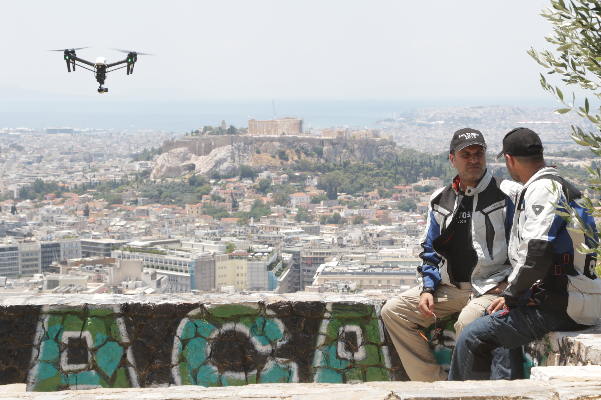

LOGLINE
Better by Bike than by Train

Back to Berlin is the first biker flick-meets-holocaust feature documentary. Eleven motor bikers have a mission to take the Maccabiah torch from Israel to the site of the infamous 1936 Berlin Olympics, for the first Jewish Olympic Games on German soil. They will retrace the heroic journeys of the original 1930s' Maccabiah riders and discover how they or their families survived the Holocaust.

“Cooler than Hells angels, these are God’s angels riding against Intolerance and Genocide” – Author, Mark J Fine

“An important and original documentary… Back to Berlin focuses
on the dynamism of a powerful and attractive group
of Holocaust survivors and their descendants.
I believe you have produced a film that will
genuinely surprise the audience
and illuminate this topic in new and intriguing ways.”
-Stephen Segaller - WNET13/PBS

“I’m so proud to be part of this brilliant documentary.”
-Larry King
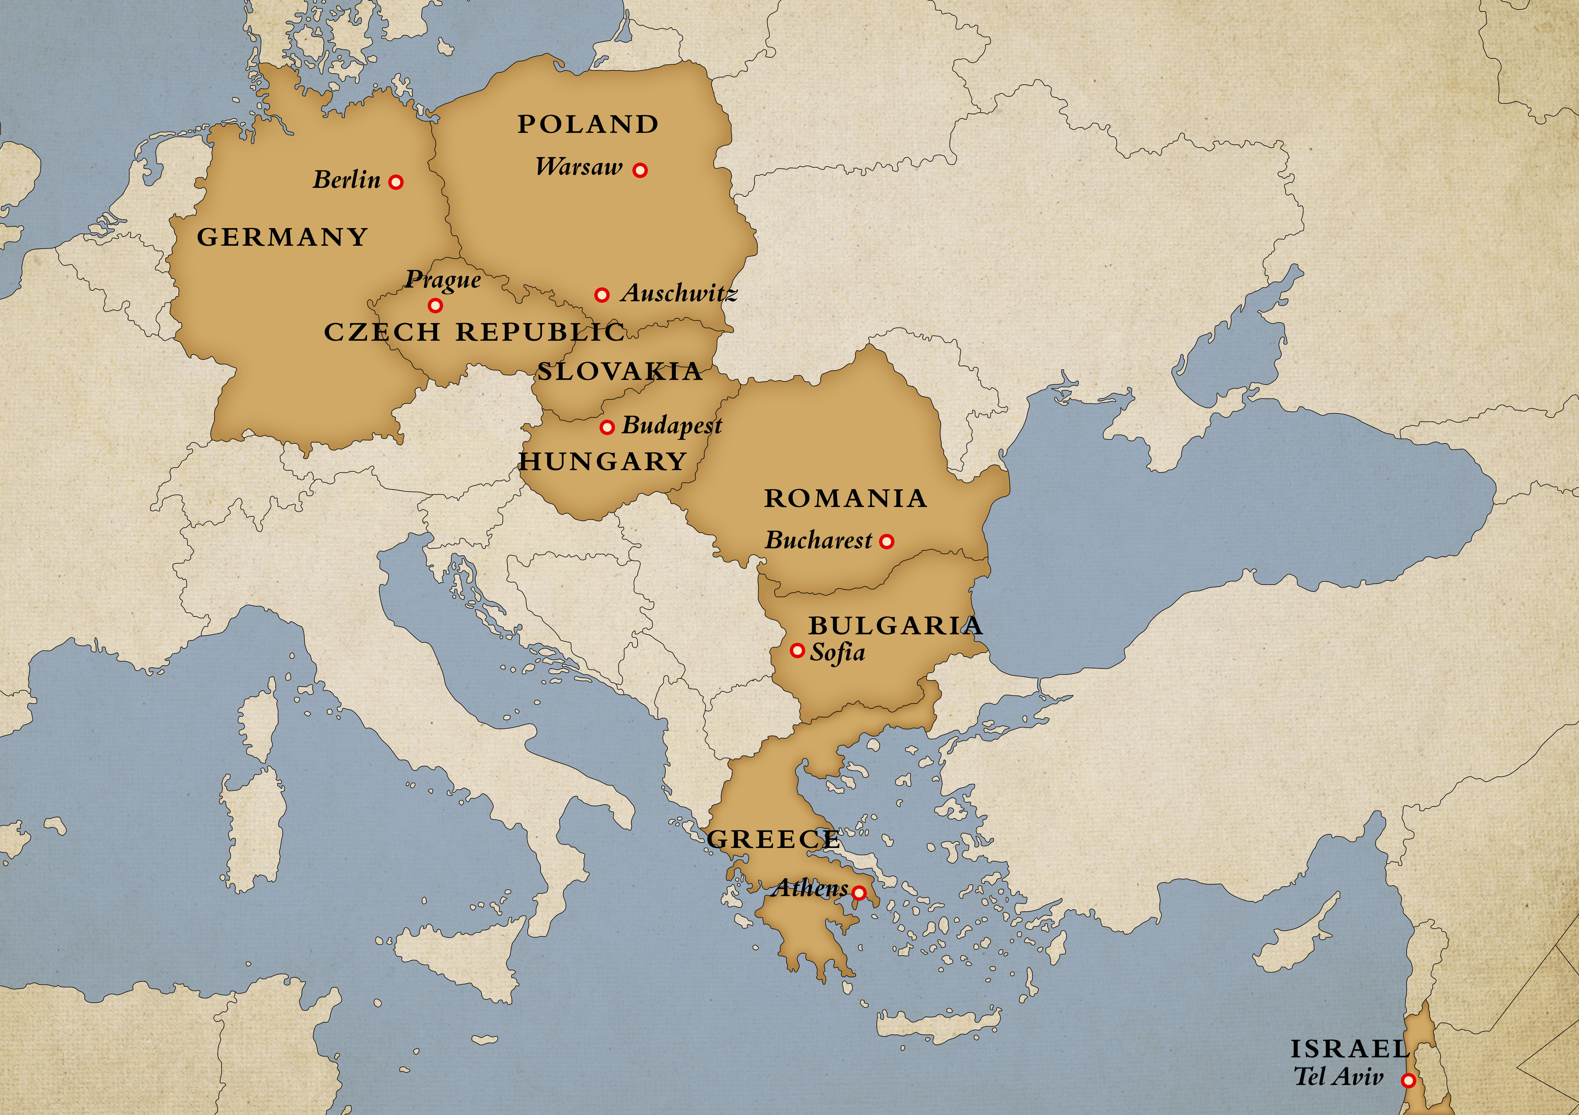

SYNOPSIS

In the summer of 2015, the European Maccabi Games, also known as the Jewish Olympics were held on German soil for the first time since WW2. Such an event, at a German venue, was once inconceivable. Yet the moment had arrived, and these 2015 Games were hosted at the Waldbühne Stadion, site of Hitler’s infamous 1936 Berlin Olympics. For Producer/Director, Catherine Lurie, this seminal event demanded the creation of a mission to take the Maccabiah torch from Israel to Berlin for the Opening Ceremony.

There is an historical precedent for the modern day Maccabiah mission. In 1930, 1931 and 1935, in one of the most innovative PR exercises of all time, Maccabiah Riders set out from the British Mandate of Palestine to all corners of Europe and America in search of Jewish athletes for the first Maccabiah Games in Tel-Aviv in 1932. The 2015 Maccabiah riders would follow in their tracks but this time taking a detour via Auschwitz.

The “Back to Berlin” cameras follow eleven modern motorcyclists, astride powerful German-made BMW machines, on an epic journey across nine countries. In the twenty-four day, 4,500 km journey, the bikers proudly fly the Israeli flag despite stormy weather, unbearable heat facing the increasing threat of anti-Semitism and populist intolerance in 21st Century Europe. At times the threat is palpable and the bikers require police protection. But the unexpected emotional toll is when the journey detours into the dark genocidal past. It is only the winds of freedom and power of their throttling machines that propel them on their mission to reach their destination.

The core group of bikers is comprised of nine Israelis and two Diaspora Jews, including two women. They are photojournalists, a TV host, a physicist, a farmer, a surgeon, an inventor, an architect and an art dealer. Seven are descendants of Holocaust survivors, two are actual survivors and two are grandsons of original 1930’s Maccabi Riders. They all have a personal reason for participating in the mission. Gal joins the ride to pay tribute to his grandfather, who was one of the 1935 Riders, and to “close a circle”.

As individuals, the bikers are painfully aware of the Third Reich horrors, however, being present as a group at the very places where family and friends were exterminated become wrenchingly real. So they sit at a rail siding in Thessaloniki, cooped up in a boiling hot cattle car, trying to imagine the intense physical and mental suffering as Kobi tells of his grandmother’s ordeal. In Bucharest they learn how Marco’s uncle was shot and left naked in the snow by the Romanian fascists. En route to Budapest, the bikers share moments with Syrian refugees separated by newly erected high barbed wire fencing as Hungary closes its border with Serbia.

There were no words of comfort as they inspect the industrial death machine of Auschwitz. And the viewer is a witness as Yoram, the Holocaust survivor, tells his adult son, Danny, for the first time, what he witnessed and how he escaped the Holocaust. His love for his family and his incredible humour is uplifting and inspirational. At Mila 18 they pay homage to the lives lost fighting the Germans in the Warsaw Uprising. They stop at Lodz and at Theresienstadt they honour Maccabi players who participated in the last football match, captured in a Nazi propaganda film, before they and the inmates were shipped to their deaths.

These are such poignant cinematic moments before their cathartic arrival in Berlin. The film uses Archival footage to take the present into the past focussing on key characters to link the 1936 Olympics, the Maccabi Games and the Holocaust.

Producer/Director Catherine Lurie recognized both the reflective irony of Jews returning to the place of their debasement, but now as a nation and athletic victors. "Back to Berlin" is a cautionary tale, but it’s also a story of reconciliation and hope. This is not just simply a Jewish story. It is a story of defiance and survival and of people overcoming the worst from fellow man to restate our common humanity.

DIRECTORS NOTE
Reminiscent of the 1930’s, populist movements from both the far right and left are once again surfacing and this is why I consider that Back to Berlin provides a necessary message.

APPROACH TO FILM

The feel of the film is one of irony. Taking a symbol of light and life of the Jewish people to the shrine of Nazi power, Berlin. The juxtaposition of the present and past is the underlying thread of the film. Throttling engines, wheels, flags, and the torch with the 2015 Maccabiah bikers mounted on their ‘metallic steeds’ portray, power, independence and freedom versus dehumanization, captivity and industrialized killing. As the riders drive up to the Brandenburg Gate brandishing their Israeli flags, and then onto the infamous 1936 Olympic Stadium in regimented formation, the audience is left to ponder this ironic moment.

The artistic approach is paradoxical. The revelations of the horrors of the individual stories of the bikers and their families are interspersed with breath taking scenic footage. Close-ups of heart breaking moments are woven with archival footage and stills to verify and punctuate the past. Hundreds of hours of footage from several cameras, drones and go pros capture every moment of this historic ride.

Via the use of birds-eye drone footage, we distort the audience’s perspective for dramatic effect. For instance, at Auschwitz the viewer initially sees an unconventional image, like an abstract painting, of grey blocks against a green background. It is only when the drone drops to a 60-degree angle, that we reveal this vast mechanized killing camp. Other particularly symbolic cinematic shots include, a herd of bleating sheep in the stupendous Carpathian Mountains (the fifth wonder of the world for motor bikers) to denote how Jews were herded into camps and the fields of sunflowers on the road to Budapest to illustrate longevity.

The style of the film is a chronological road trip, delving into the past from Israel to Greece, Bulgaria, Romania, Hungary, Poland, Czech Republic and ending at their destination, Berlin. Stories are told through the characters. The narrator is used sparingly for the explanation of archival footage. We use personal photographs from the 2015 bikers of their family members and relatives affected by the Holocaust.

I have developed the style and feel of the film by building on key characters, showing footage of their lives in Israel, their personal reasons for joining the journey, and the impact on their lives after undertaking this journey.

ABOUT THE FILMMAKERS

CATHERINE LURIE (DIRECTOR, WRITER, PRODUCER)
Catherine Lurie-Alt is a film producer and journalist based in London. She was the youngest investigative Journalist ever appointed to the Business section of the Sunday Times in South Africa. Currently she is the European Correspondent for the New York-based TV Chanel JBS and is a member of the Foreign Press Association. Catherine conceived the idea of Back to Berlin after working as a correspondent covering the 2013 Maccabiah Games in Israel, where she found, produced and directed five other human interest stories. Catherine has had a long association with the Maccabiah. She joined the Committee of 18 in LA in 2011 and the Board of Trustees for Maccabi World Union (MWU) in 2013. She is also a UK member of the European Jewish Parliament. Her company, Luria Media, is developing and producing multimedia projects focusing on subjects relating to humanitarian causes and foreign politics.

LARRY KING (EXECUTIVE PRODUCER)
Larry King was born November 19, 1933 in Brooklyn, New York. In 1978 he started a nightly coast-to-coast radio talk show, The Larry King Show, on the Mutual Radio Network. This work caught the attention of Ted Turner, who hired King to host his own talk show, Larry King Live, on CNN from 1985 to 2010. His work has been recognized with two Peabodys and ten Cable ACE awards. Larry King has given his valuable time and endorsement to this project to bring it to fruition.

ROSA RUSSO (LINE PRODUCER)
Rosa is an award-winning producer and director: her experience ranges from creative to logistical, and she has taken on projects of different strands of the film industry from any stage. Rosa started her career as a theatre Assistant Director and Light Designer but soon moved in the film industry working as First Assistant Director with established Italian independent filmmakers. Rosa has gone on to become an accomplished Producer, with some of her films selected to participate in international festivals. Her titles include ‘Capo Nord’, ‘Le Vite degli Altri', ‘Borges and I’, and ‘May I Kill U’. Her directorial debut, the documentary ‘Everyday But Sunday’ won the 2010 Unicef Award at OETI.

ANDREW QUIGLEY (EDITOR)
Andrew studied photography, music and sound engineering at Birmingham. He won the British Institute of Professional Photography Scottish print awards in 1990 with an Architectural study in Port Street, Annan. He moved into documentary films, where he has worked extensively for BBCTV and Channel Four together with International Broadcasters and theatrical producers. He was BAFTA nominated in 1998 for ‘The Heart and Soul of Eric Morecambe’ and won official selection at Toronto International Film Festival and the Special Jury Award at B.I.F.F. 2006 for the feature documentary ‘Diameter of the Bomb’, which he directed and edited.

JULIAN RODD (EDITOR)
Julian recently completed cutting with Terry Jones on ‘Absolutely Anything’ starring Robin Williams in his final role. Past films include 'The Walker' for Paul Schrader and 'The Secret of Moonacre' by Gabor Csupo. He has edited a variety of documentaries, from 'A Company of Soldiers', to drama documentaries such as the final episode of 'Dunkirk'; and two of the Howard Goodall Channel 4 music series, all of which have been nominated for awards. In 2011 Julian edited the pilot for the 2014 TV BAFTA winner ‘Long Lost Family’. He was part of the multi Emmy nominated 2013 series ‘The Bible’.

MICHAEL STEVENS (COMPOSER)
Michael composed and produced the score and title song for Clint Eastwood’s acclaimed drama “Gran Torino,” for which he received a Golden Globe nomination for Best Original Song. He also wrote the original scores and songs for Eastwood’s "Invictus," "Changeling," “Letters from Iwo Jima,” “Flags of Our Fathers,” “Million Dollar Baby” and “Mystic River.” He scored the documentary “An Unlikely Weapon,” which won Best Documentary at the 2009 Avignon Film Festival. In 2010 Michael wrote the original score for the documentary "Pieds Nus Sur Les Limaces", which received the art cinema award in Cannes. His work also includes the French Thriller "Dans La Tourmente" and "Medecin Chef". His work with the Italian director Bruno Oliviero in "La Variabile Humana" was chosen for the opening night of The Locarno Film Festival in Switzerland.

YOSEF GRUNFELD (CONSULTANT)
Yosef teaches Editing at the The Steve Tisch school of Film and Television, the Tel Aviv University and The Sam Spiegel film & TV school, Jerusalem. In his successful career he has contributed to many feature films and documentaries. Among them: Things Behind the Sun, Walk on Water, Beitar Provence and The Bubble. He received four nominations as Best Editor Award from the Israeli Film Academy.

NARRATORS

JASON ISAACS

Jason Isaacs was born in Liverpool, the third of four children of Sheila and Eric Isaacs. His parents were both from Jewish families (from Eastern Europe). He studied law at Bristol University and graduated in 1985 with a degree in law but decided to study acting. While at Bristol University, he directed and/or appeared in over 20 productions. He then attended the Central School of Speech and Drama and graduated in 1989.
Jason's notable roles include Col. William Tavington in The Patriot (2000), Lucius Malfoy in the Harry Potter films, Mr. Darling/Captain Hook in Peter Pan (2003), and Maurice in Good (2008). In 2014, he appeared with Brad Pitt, Shia LaBeouf, Logan Lerman, and Jon Bernthal in the World War II-set film Fury (2014).

ABOUT THE CAST

GAL MAROM (49) - Biker – Israel – Architect
Gal’s grandfather, Solomon Adir, was one of the original Maccabiah Riders of 1935. He was 21 when he joined the expedition taking off from the British Mandate of Palestine to spread the word for the 1938 Games. This event was never to materialize. The journey took the riders from Europe to the USA and Canada. Their mission became a show of strength against the 1935 Nuremberg Laws. ”I came on this trip to honour the man who raised me and infected me with his love for biking and the Maccabiah”. This journey allowed me to close my personal circle in memory of my grandfather”.
KOBI SAMUEL (48) - Biker - Israel and Greece - Art Dealer “Our joker”
In 1942, 12 years old, Martha Angel, Kobi’s grandmother was one of circa 56,000 Thessaloniki Jews deported to Auschwitz. In 1945, as the Russians were advancing the Nazi’s led all surviving inmates on a death march towards Germany. In the middle of the night, Martha and four Greek girls escaped into a thick forest until they met a Russian Tank Commander. Revealing the Star of David from under his uniform he said “I will save you.” His grandmother still lives today. For Kobi revisiting his families’ birthplace and seeing Auschwitz was emotional.
YORAM MARON (78) - Biker – Poland/Ukraine and Israel- Physicist, and a survivor
In 1939 Yoram and his mother, Irena were taken to Zloczow Ghetto. In 1943, all ghetto residents were herded to the railway station. Their final destination was the death camp Bełżec. When a railway man managed to open a door of the running train, Yoram’s mother flung him out of the wagon and jumped out after him. They would be the only two survivors of this transport. They hid in a bunker until the end of the war fed at night by a German soldier who was later named in Yad Vashem. The film gave Yoram the platform to tell his story for the very first time to his 48 year old son Danny.
DANNY MARON (48) - Biker – Israel - Press Photographer
He is the son of Yoram Maron, our 78 year old heroic Holocaust survivor and biker. The film catapulted his father to tell him his story of survival for the first time. When asked why his father waited 48 years to tell him of his gruesome ordeal, Danny’s reply was “Perhaps he wanted to afford me the innocence he himself never experienced, and I will do the same with my own children.” Danny played a key role in guiding and ensuring the safety of the bikers en route to Berlin. He proved to be a man of compassion having a positive influence over the group and a fiery soul.
MARCO MAXIMILLIAN KATZ (56) - Biker – Romania - Marco is in the hospitality industry
Marco’s grandfather and uncles were tortured and killed by the Romanian Legionnaires. In 2002, following a severe anti-Semitic attack on himself, with the assistance of the ADL (Anti-Defamation League) he established The Center for Monitoring and Combating anti Semitism in Romania. “It is a demanding and not always rewarding activity. It often puts me in awkward situations with anti-Semites and Holocaust deniers as well as with Jewish and Israeli fellows. But I joined the ‘Back to Berlin’ journey to continue to fight anti-Semitism, discrimination and racism with the same stubbornness.”
ALEXANDER ROSENKRANZ (60) - Biker - Hungary and Germany – Businessman
He is the leader of the German bikers who joined the the 2015 Maccabiah Riders. Alexander’s mother was born in Budapest and survived the Hungarian fascists, the Nyilas (Arrow Cross), when they trucked her and other Jews to the Danube to be shot. She was saved by a German Nazi soldier simply ‘because she was beautiful’. He tells the story of his mother to his daughter for the very first time at the Shoes of the Danube memorial. In 1920 Hungary introduced the Numerous Clausus Law, which is often seen as the first anti-Jewish act of the 20th Century.

JOE GOTTDENKER (73) - Biker - Poland and Canada -Businessman, survivor and philanthropist
In 1942, Joe’s father, Ben was deported to a labour camp. After giving birth to Joe, his mother found refuge with a Polish Catholic family on the outskirts of Sandomierz. Joe’s mother was forced to leave her son with their brave host Catholic family. She joined the Polish Partisans and was not to see Joe for the next three years. Joe found it difficult to be reunited with his natural parents. Joe is a great benefactor to Yad Vashem and other institutions. For him to take part in this ride “was sending out a signal”.
GILI SHEM TOV (40) - Biker - Israel and Bulgaria- Former TV presenter
Gili Shem-Tov started investigating her grandfather’s life in Bulgaria after being asked to participate in the project. She discovered that the King of Bulgaria was pro-Nazi and that it was the Bulgarian Church and certain members of parliament who stopped the deportations of Jews “This saved my great aunt’s life at the very last minute”. Gili joined the journey despite being pregnant. I had to come. At times I could not bear knowing what had happened to the families of other bikers. It was hard emotionally and physically. But I would not have missed it for the world.”
YARON MUNZ (56) - Biker - Israel and Romania - Surgeon
His mother, Riri, immigrated to Israel in 1951 from Romania. At the age of 6, she was sent to a labour camp in Transnistria. Like the majority of the bikers, he was told little by his parents about their experiences at the hands of the Nazis and their collaborators. It was during filming that he discovered that his grandfather, Leopold, was held and tortured at the same Bucharest prison as Marco Katz’s relatives. Dr.Munz showed great insight into the relationships and dynamics of the 2015 bikers and proved an invaluable participant.
HILA FENLON (38) Biker – Israel - Farmer
A mother of two and a resident of Netiv Ha Asara on the border of the Gaza strip. Hila’s children sleep in a bomb shelter and she wants peace with Palestine. She fears for her family’s safety in the current climate. During the recent conflict of Operation Protective Edge, Hila would frequently find tunnels in the back of her garden dug by Hamas Militia. With the extreme danger of her family’s living situation, and the recent boycotting of Israeli products, her life as a farmer on the border of the Gaza strip is in question. Hila is faced with the age old question: “Should I leave or should I stay. But where would I go?”
ELEN KATZ (49) - Bike Manager – Poland/Austria and Israel - Inventor and security expert
Being a seasoned biker he was contracted to manage biking matters for the expedition. “When I was asked to be involved in the project, I began researching the original 1930 bikers’ journeys. I then miraculously discovered that my grandfather, Nathan Blumenthal, was one of the 11 Polish bikers who escaped to the British Mandate of Palestine in 1933. I now know that biking is in my DNA”.
ZIV KOREN (44) - Biker – Czech Republic and Israel – Photojournalist
His mother, Mickey, came to meet him and the bikers in Prague to tell the story of her father, Dr Reuven Paul Zellig: he studied medicine at the University of Prague but resigned his post as a doctor because he refused to give the daily Nazi salute. He went on to save 1,500 Jews taking them to Palestine by boat. To this day, Mickey will never forgive Germany. She will neither buy their goods nor visit her son’s exhibitions in Berlin. Ziv says, “This journey is something I had to do”.
DANI CUSHMARO (47) - Biker and Newcaster - Israel
Dani Cushmaro is one Israel’s leading TV Anchors. He hosts the primetime Channel 2 News “Ulpan Shishi” (Friday Studio) program. Dani’s role in the Back to Berlin documentary was as a journalist for Channel 2. He joined the project out of his love for biking and his interest in the subject matter. He is an avid historian, with particular interest in World War II. His parents hail from Romania and moved to Israel in the mid-sixties.

A CAT-MAC PRODUCTION
WRITTEN, PRODUCED AND DIRECTED BY
CATHERINE LURIE
EXECUTIVE PRODUCERS | ANTHONY ALT  ELLIOTT BERNERD  LARRY KING  STUART URBAN
NARRATORS
JASON ISAACS
LARRY KING
ASSOCIATE PRODUCERS
PETER KELLY
PHELIM MCALEER

ASSOCIATE PRODUCERS
SERGE RAFFET
DEWEY WIGOD

EDITORS
ANDREW QUIGLEY
JULIAN RODD
CINEMATOGRAPHER
EYAL BEN YAISH
COMPOSER
MICHAEL STEVENS
LINE PRODUCER
ROSA RUSSO
CONSULTANTS
YOSEF GRUNFELD
RODNEY SONDERS
DAVID HUGHES
MARTIN WINSTONE
FEATURING
HILA FENLON
JOE GOTTDENKER
ELEN KATZ
MAXIMILLIAN MARCO KATZ
ZIV KOREN
GAL MAROM
DANNY MARON
YORAM MARON
YARON MUNZ
ALEXANDER ROSENKRANZ
JACOB SAMUEL
GILI SHEM TOV

AND
DANI CUSHMARO

EDWIN ADAMEK, ELICE AVRAHAMI, DAFNA BERGER
JEAN COHEN, PETER GONCI, ALBERTO HAZAN,
VICTOR HAZAN, ANDREAS HEISLERDA, NIEL HOFFMANN,
JOZSEF HORVÁTH, KAROLY HORVATH, MARIO IEHASKIEL,
OREN ITZHAKI, GABOR KALOTAI, CSABA KORDOVAN,
MICKEY KOREN, PETER AVI KOVACS, SANDOR LUKACS,
ELLA MARON, GYORGY MIHALY, SERGE MORDOH,
ANGEL NARGO, DAVID NEGRIN , MANUEL NYMAN
DANIEL PASSENT, GLESER PHILIP, TALIA ROSENKRANZ,
BORIS ROSENTHAL, LEONID ROSENTHAL, ZIVA SHMUL
EYAL TIEBERGER, EDUARD VIGODSKI

SUPPORTERS
MACCABI WORLD UNION
DAVID DE ROTHSCHILD
DAVID LOURIE
M S A SHINE
THE KROLL KIDS FOUNDATION
THE KIRSCH FOUNDATION
JONATHAN LOURIE
PATRICIA KENNER
GEORGE BLUMENTHAL
ANN & STEVEN STOLLER
TOVAH FELDSCHUH
SZOR FAMILY
STANLEY VICKERS
KENNETH EPSTEIN
MAGGIE GOLDSTEIN
GORDON MOSKOWITZ
CHAVA ALTER
STEWART CAHN
A H LEVY
ESTER BRAVER
ELIOTT ROSE
CAROL LIPSKY

