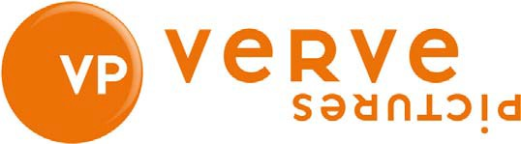

BENJAMIN

A film by Simon Amstell

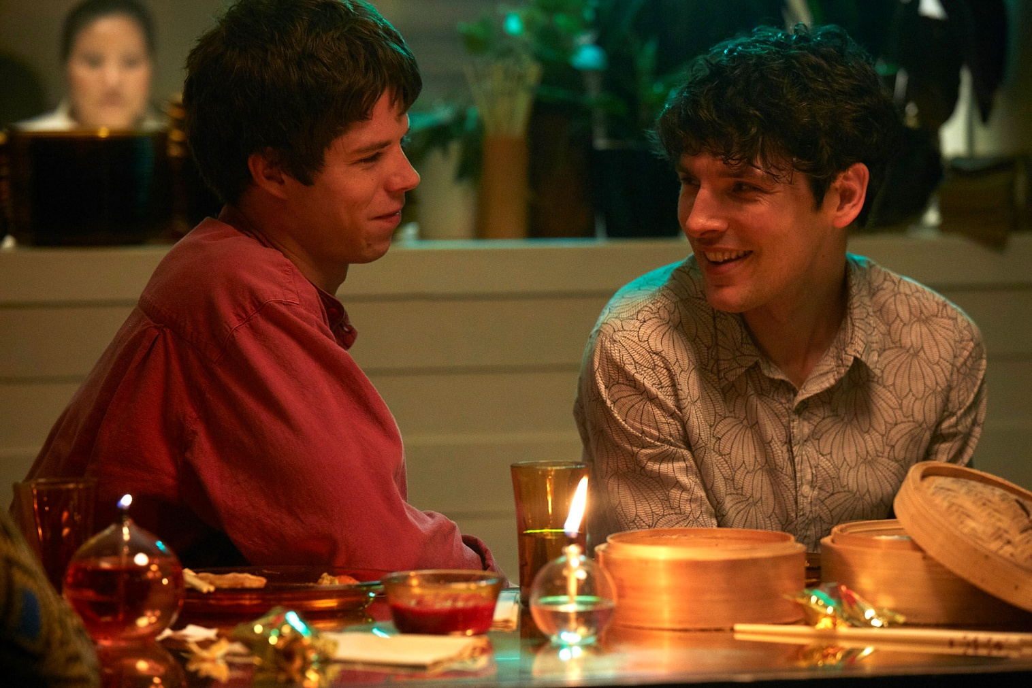

For all publicity enquiries please contact:
press@openpalmfilms.co.uk
Certificate: tbc /Running time: 85 minutes
SHORT SYNOPSIS
Benjamin, a rising star filmmaker, is on the brink of premiering his difficult second film ‘No Self’. He has been too long in the edit.
On the eve of the premiere at the London Film Festival, he is introduced to a mesmeric French singer called Noah.
As they journey through a contemporary London of vegan restaurants, comedy clubs and avant-garde dance, they slowly manoeuvre themselves and each other towards love.

Benjamin is a drama-comedy about feeling isolated and struggling for connection.
SYNOPSIS
Following the award winning success of his debut seven years ago, Benjamin sits in the edit room agonising over the minutiae of his new film, ‘No Self’. It stars himself, cast opposite hip young actor Harry, in an autobiographical film about love and disconnection. “I don’t know who I am if this isn’t good”, he complains to his producer.
Home, for Benjamin, is a one bedroom flat in North London with a cat, where he wastes long nights watching meditation videos on YouTube and over- eating ice cream.
The zealous but equally callous Billie, his Press Rep, arrives at the flat to take some shots for his new film, and invites Benjamin to a party launching a new range of chairs. Reluctantly Benjamin goes accompanied by his best friend, Stephen, an unsuccessful comedian. They quickly realise, in the depths of East London, that the crowd is a generation just out of step with their own.
Before they leave, Benjamin finds himself captivated by the band on stage, in particular their young lead singer, French music student Noah. Opting to stay, Benjamin fumbles through a conversation with him, and is invited to dine with the band. Noah’s a vegan too… and they end up spending the night together.
The premiere of Benjamin’s film, ‘No Self’, is held at Curzon Soho as part of the London Film Festival. It is a disaster. Amidst this professional crisis for Benjamin, Stephen has a row with Billie, and Benjamin with Stephen. As if things couldn’t get worse, Noah doesn’t think that he’s ready for a relationship. A minor meltdown ensues, capped by a pasting for his film from Mark Kermode and Simon Mayo.
Benjamin’s career is in crisis, his best friend Stephen’s comedy can’t raise a laugh, his other relationships seem phoney and the world seems terribly impressed by rubbish.
How can Benjamin finally get out of his own head and open himself up to the reality of being loved?

DIRECTORS STATEMENT
Benjamin is a film inspired by my own painful attempts at love, having prioritised my career over anything else from the age of thirteen. It is an exploration of what it would take to break someone free of their loneliness and depression, of their carefully constructed ‘self’. I came to understand that I, like Benjamin had been seeking the love of an audience, when what was really needed was some actual intimacy. Benjamin shows that journey, forcing a character to confront the limitations of their defence mechanisms and see that without them, they would be free.

I was sat on the train coming home from the Edinburgh Fringe, I opened my laptop and just started to write scenes from every relationship I had ever been in. Two relationships stood out as the most conflicted and funny. One of the relationships took the lead and the second relationship became the basis for Benjamin’s film within the film.

I had fun contrasting the pretentious film the character makes - ‘no self’, where the presence of the filmmaker is very evident, the shots consciously showy and deliberate, with the hopefully more invisible choices we made. The challenge was to make something romantic, yet authentic, so the scenes are purposely not overly lit, overtly designed or graded, the goal was to make the love story feel like it was just being subtly captured.

The ending came about only because I didn’t call ‘cut’ straight away when we shot the last scene. I really loved what Collin Morgan did once he’d run out of lines. And in the edit, we felt like his instinctive response was exactly the ending that both the film and the character needed.

Colin Morgan is very funny and completely believable, which is rare. I was keen for Colin to act in his own accent. (this will be the first time Colin acts in his own accent.) My only concern was his body. I asked if he thought he could become a bit less of a hunk by the time we started shooting but in the end thought that the character's obsession with Buddhism could possibly also extend to doing too much yoga.

Noah’s character was a little trickier to cast. We auditioned a lot of very talented British actors but something always felt a little off. In story terms, we just needed Noah to be from somewhere other than London and I think the original idea was to have him be from Yorkshire. Then in desperation I asked the casting director if we could maybe find a French or Spanish Noah. I then remembered a young French actor called Phenix Brossard I’d seen in a film the year before. And when Phenix came from Paris to audition, his chemistry with Colin was just incredible. He was so loose and French! There’s a bit where the character takes his top off in the script. All the other actors who auditioned, had quite appropriately mimed taking their t-shirts off and Phenix just threw his off and went to kiss Colin. It felt like something was really happening.

I worked with James Righton to create the music. We had such a great time in his basement studio coming up with Noah’s songs. Phenix sang each of the songs live and we put together a band of musicians rather than actors to play his bandmates. James also acted as musical director on those shooting days.

Simon Amstell

CAST

COLIN MORGAN - BENJAMIN
Colin is a Northern-Irish actor based in London. He is a well-established presence on British screens and is best known for his role, as the titular character in the BBC fantasy series Merlin, and as Leo in the Channel 4 sci-fi drama Humans. His stage credits include Gloria at the Hampstead theatre and The Tempest at The Globe. He can currently be seen at the National Theatre in Translations directed by Ian Rickson. Colin is also known for playing diverse roles in film and can now be seen acting opposite Rupert Everett in this years Oscar Wilde biopic The Happy Prince.

PHÉNIX BROSSARD - NOAH
Phénix is a young French actor originally from Paris. He has acted extensively in French film and television. Following his feature debut in La Lisiére (The Edge), Phénix is best known for his role in Andrew Steggall’s Departure opposite Juliet Stevenson and Alex Lawther, and for his recurring role on the Sky Atlantic drama Riviera. He is an exciting up and comer with projects lined up throughout the year.

JOEL FRY - STEPHEN
Joel is a British actor who trained at RADA. His recent credits include Dave in Sky One’s comedy-drama You, Me and the Apocalypse, Billy Tokington in Ordinary Lies, and as the lead in supernatural drama Requiem for the BBC on Netflix. Joel may be best known for his roles in cult comedies Plebs for ITV2 and Trollied for Sky. As well as recurring parts in HBO’s Game of Thrones and the BBC mockumentaries Twenty Twelve and W1A.

JACK ROWAN - HARRY
Jack is a young British actor, though his credits already include series regular Bonnie Gold in Peaky Blinders and the lead role in the hit Channel 4 drama Born to Kill. His performance in the latter earned him a BAFTA nomination this year competing against Sean Bean. An equally accomplished amateur boxer with 27 competitive bouts to date, Jack is one to watch in a new wave of British talent.

JESSICA RAINE - BILLIE
Widely touted by the media as one of our brightest young talents Jessica has worked extensively across TV, Film and Theatre since graduating from RADA. Her many credits include Jenny in Call the Midwife, the role of the Nanny in The Woman in Black and Cleo in Rocket to the Moon at the National Theatre. She can currently be seen in the Sky Atlantic drama Patrick Melrose alongside Benedict Cumberbatch and in the feature film Carmilla later this year.

ANNA CHANCELLOR - TESSA
Anna is a BAFTA and Olivier nominated British actor. She is a prolific figure on British screens and has an established presence both on stage and internationally. Some of her most iconic roles include Mercedes Page in Jupiter Moon, Henrietta in Four Wedding’s and a Funeral and Caroline Bingley in Pride and Prejudice. More recently she has appeared in Showtime’s Penny Dreadful, Testament of Youth and Netflix’s The Crown.

FILMMAKERS

SIMON AMSTELL - WRITER/DIRECTOR
Simon Amstell is a British comedian, television host, screenwriter, director and actor. Simon began his career on television as the host of Channel 4’s popular music and pop culture program Popworld. He then went on to host the hit comedy show Never Mind the Buzzcocks for which he won two British Comedy Awards as well as a Royal Television Society Award for Best Entertainment Performance.

In 2009, BBC2 commissioned Simon to write and star in Grandma’s House. The critically acclaimed show went on for two seasons and won a British Comedy Award.

As well as continuing his stand up career, touring internationally and making Do Nothing which was broadcast on BBC2 and Numb, which can now be seen on Netflix, Simon has directed two short films, Something More, chosen for Channel 4’s Random Acts and William, a short produced by Tiger Aspect productions. In 2017 Simon directed a mockumentary for the BBC iPlayer entitled Carnage. The film is set in a future and looks back at a time when human beings ate other animals. Benjamin is Simon’s debut feature film.

DOMINIC DROMGOOLE - PRODUCER
Dominic Dromgoole has worked extensively in theatre around the world and was artistic director of The Globe from 2006-2016. In that time, he mounted over a hundred productions including thirty new plays, and redefined the theatre as a centre of radical scope and ambition. Dominic and his team created a national touring circuit, and an unprecedented international network, which brought productions from 40 different countries to the Globe, and from the Globe to every country in the world. He also planned and built the Globe’s new indoor theatre, the Wanamaker Playhouse. It was at the Globe that he gained his first taste for film production after developing a video-on-demand platform for Globe productions, and making and showing 37 short films, celebrating Shakespeare’s plays in their real settings.

Previous to The Globe Dominic worked as Artistic Director at The Bush from 1990-96. He was in charge of new plays with Sir Peter Hall’s company at the Old Vic in 1997, and ran the Oxford Stage Company from 1999 to 2005. He has written many essays for the Sunday Times, The Guardian and the Telegraph; has worked as a columnist for the New Statesman and the Guardian, and has written three books, The Full Room, Will & Me and Hamlet: Globe to Globe.

Since leaving the Globe, Dominic’s theatre company Classic Spring has produced the critically acclaimed Oscar Wilde Season at the Vaudeville theatre in 2017/18.

In 2016 Dominic set up Open Palm Films with the remit of creating small budget chamber epics. So far he has produced five films for the company: Making Noise Quietly, which he also directed, Pond Life, Undercliffe, Tides and Benjamin. Further directing and producing projects are underway for later on this year.

JAMES RIGHTON - COMPOSER
James is an English musician best known for founding and performing in the band the Klaxons. Together they won a Mercury Prize for their album ‘Myths of the Near Future’ and dedicated over a decade to British music, becoming one of the most recognisable bands of the day.

Since departing the band James has released new music under the moniker Shock Machine and continues to develop solo projects.

He composed the music for, and performed, in the Simon Amstell short film Something More and the 2012 short film First Song. Benjamin is his first feature film.

ALEXANDRA BREEDE - PRODUCER
Alexandra Breede is a Canadian/German producer working in the United Kingdom. She has produced four films with Open Palm Films, Making Noise Quietly, Undercliffe, Pond Life and Benjamin. Prior to joining Open Palm, Alexandra worked at the Globe Theatre where she associate produced the Complete Walk short film project.

Alexandra graduated from the National Film and Television school where she produced a number of short films, including Group B, which was nominated for a Student Academy Award won the RTS Award for Graduate Fiction. Further credits include Fulfilament and Pioneers. Collectively these shorts have screened in over 60 festivals worldwide including AFI, TIFF and KIDS. Alexandra is currently developing her own slate of films

LOUISE SIMPSON - PRODUCER
Louise Simpson is an independent film producer. She began working in the film industry after graduating from Oxford University where she read English Literature. She worked her way up through the ranks, working with Andrea Arnold on Wuthering Heights and Chris Young on The Inbetweeners Movie. In 2012 Louise went on to produce the short film On This Island, starring James Norton, which won Best British Short at Encounters Film Festival and the Golden Egg at Reykjavik. Louise worked as a post-production assistant on Paddington and continued to work in post management capacity for Star Wars: Rogue One, Everest and Bohemian Rhapsody.

Benjamin is Louise’s first feature as producer. She is currently developing her own slate of features and shorts.

OPEN PALM FILMS
Hamlet’s advice is sharp. He warns not to overstep ‘the modesty of nature’. Nature is not bombastic, or sensational, or majestic, nature is itself, and modestly so.

There is an old myth about the word sincerity. Old sculptors used to adulterate the materials they used with wax, and thus a pure piece of sculpture would be stamped ‘sine cera’, without wax. Truthful work is without wax, it is sincere.

Open Palm Films aim to be modest and sincere, to be light and funny, and to celebrate the tender power of truth.

Open Palm Films have made six films thus far, Making Noise Quietly was the first.

WRITTEN and DIRECTED by
Simon Amstell

CAST
Colin Morgan as BENJAMIN
Phénix Brossard as NOAH
Joel Fry as STEPHEN
Jack Rowan as HARRY
Jessica Raine as BILLIE
Nathan Stewart-Jarret as PAUL
Ellie Kendrick as ANNA
Anna Chancellor as TESSA

Kriss Dosanjh as MONK
Arnab Chanda as GURU
Joanne Howarth as SHOPKEEPER
Mariam Haque as FILM FESTIVAL HOST
Alex Lowe as COMPÈRE
Robin Peters as EDITOR
James Bloor as ALEX
Jessie Cave as MARTHA
Michelle Belgrand as ADRIENNE
James Lailey as CLAUDE

PRODUCER
Dominic Dromgoole
Alexandra Breede
Louise Simpson

EXECUTIVE PRODUCER
Mark Coombs

MUSIC by
James Righton

DIRECTOR OF PHOTOGRAPHY
David Pimm

ASSOCIATE PRODUCER
Emma Green

EDITOR
Robin Peters

PRODUCTION DESIGNER
Hannah Purdy-Foggin

COSTUME DESIGNER
Oliver Cronk

MAKE-UP AND HAIR DESIGNER
Chloe Edwards

CASTING DIRECTOR
Matilda James

GENERAL MANAGER
Rosie Townshend

EXECUTIVE COORDINATOR
Alice Schweitzer

DIGITAL ASSISTANT
Pasha Tong

